Franchise Operations Manual

Microsoft
Thermotec Group
03 5022 1671
03 5023 7893
5/25/2015
Kirstie Michalski
Thermotec Group

CONTENTS

SECTION 1 – OVERVIEW
- Confidentiality Agreement
- Franchise Code of Conduct
- Operations Manual
- Welcome to Thermotec
- Your franchise
  - What kind of business should I be?
  - Planning and establishing your business
  - Undertaking your initial training
  - Marketing your business
  - Recruitment
  - Budgeting & Forecasting
  - Developing your business
  - Stock Purchasing
  - Operating hours
5.10 Performance

SECTION 2 – STAFFING
- Recruitment
  - Advertising the position
  - Screen Candidates
  - Schedule the interviews
  - During the interview
  - Conclusion of the interview
  - Conduct 2nd interviews if required
  - Assessing candidates
  - Conduct reference checks
  - Offer the preferred candidate the position
- Orientation
  - First Day
  - First Week
- Terms and Conditions of Employment
  - National Employment Standard’s
- Probation Period
  - Successful completion of probation
  - What to do if an employee is unsuitable for the role?
- Position Descriptions
  - Position Descriptions
- Managing your people
- Wages
  - Payment of Wages
  - Calculation of Salary/Wages
  - Payroll weekly cut off
- Leave Entitlements
  - Annual Leave
  - Sick & Carers Leave
  - Compassionate Leave
  - Maternity and Parental Leave
  - Public Holidays
  - Long Service Leave
  - Workers Compensation
  - Trade School

- Fringe Benefits Tax
  - Types of fringe benefits
  - Do you need to pay FBT?
  - How to register for FBT
  - How to report, lodge and pay FBT
  - FBT exemptions and concessions
- Workers Compensation
  - Who to contact for workers’ compensation advice and help
- Superannuation
  - How much superannuation does an employer have to pay?
  - Other superannuation contributions
- Discrimination and Equal Opportunity
- Harassment & Bullying
- Dispute Resolution
- Performance Management
  - Conducting a performance review
  - Dealing with poor performance
- Resignations
  - Resignation periods
- Termination of employment
- Instant dismissal/serious misconduct
  - What is serious misconduct?
  - What is the next step?
- Personnel files
- Staff Discount
- Employee Grievances
- Staff Starter Pack

SECTION 3 – ADMINISTRATION
- General policies
- Confidentiality
- Personal belongings
- Notice board
- Office telephone
- Office computer
- Alcohol/illegal substances
- In store music
- Promotions
- Uniforms
- Personal hygiene
- On call rostering
- Keys
- Codes
- Petty Cash
- Invoicing
- OH & S
  - Hazard Reporting
  - Emergency procedures
  - Injury/incident reporting & investigation
  - Hazardous substances/dangerous goods
  - First Aid
- Daily procedures
- Employers Duty of Care
- Employees Duty of Care
SECTION 4 – OPERATIONS
- Operations
- Weekly employee time sheets
- Ordering
  - Ordering products
  - Ordering from alternative suppliers
  - Prices
- Obtaining Insurance
  - Mandatory insurances
  - Other insurances
  - Workers compensation
  - Personal accident and illness
- Licence Requirements
- Cash Flow Budget
- Franchise payment to Thermotec
  - Payment of royalties
  - Payment of marketing levies
  - Payment for other services
  - Payment for products
- Cleaning
  - Cleaning agents
  - Ongoing cleaning
- Display products
- Customer complaints
  - Abusive customers
  - Serious complaints
- Business Security
  - Theft
- Customer service
  - Consistent trading hours
  - Efficient customer service
  - Pleasing store aesthetics
  - Staff trained appropriately
  - Manage, measure and improve
- Customer telephone enquiries
  - standard telephone conduct
- Minimum Company Stock Requirements

SECTION 5 – MARKETING
- Marketing activities
- Marketing approval
  - How do you get marketing approval
- Brand values
- Brand imagery
  - Logo
  - Font
- Company vehicles

Section 1 - Overview

Confidentiality Agreement
This manual and any files transmitted with it are confidential and intended solely for the use of the individual or entity to which they are addressed. This manual contains confidential information and is intended only for the individual named. If you are not the named addressee you should not disseminate, distribute or copy this manual. If you are not the intended recipient you are notified that disclosing, copying, distributing or taking any action in reliance on the contents of this information is strictly prohibited.

About the Franchise Code of Conduct

Purpose
The Franchise Code of Conduct code aims to regulate the conduct of participants in franchising towards each other and to ensure that they are sufficiently informed about a franchise before entering into it. The code also provides a cost-effective dispute resolution scheme for franchisees and franchisors.

The Australian Competition & Consumer Commission (ACCC)
The ACCC regulates the Franchise Code of Conduct and promotes compliance with the code by helping people understand their rights and obligations under the code and the Competition and Consumer Act. The ACCC are also responsible for investigating complaints and, where necessary, taking enforcement action against anyone who fails to comply with the code.

Audit Requirements
Thermotec may audit or organise someone to audit your accounts for accuracy. Thermotec will cover the cost of the audit unless the Franchise Agreement states for otherwise. Penalties may apply if you do not report accurately.

The Operations Manual
The purpose of the Operations Manual is to assist you through the operation of your franchise. To answer most of your questions, you should first look within the Manual before contacting the appropriate head office person. You are loaned a copy of the Operations Manual (or provided access online) for the period of your franchise term. Always make sure you are using the most updated version of the Operations Manual, as Thermotec may issue an update for the benefit of the franchise network.

Operations Manual Restriction
The Operations Manual is restricted to your sole usage during your franchise term. It is highly confidential and its content may only be used in your business. The Operations Manual must not be copied or shared. Ensure to keep your passwords for online access private and if retaining a hard copy, make sure it is secure, but available for access if required. You will be required to inform head office in writing when you have acknowledged receipt of the manual (or access to the online version) and understand the terms for its use.

If you require any further assistance, please contact Thermotec Head Office on the details below:

Daryell Scase 0417 356 223

Kirstie Michalski 0428 180 191

Welcome to Thermotec
Thermotec Group provides you with a highly skilled and experienced mechanical team with expertise in Refrigeration and HVAC to fulfil all your company’s requirements.

We offer 24/7 response and cover all levels of mechanical contracting requirements for:
- Supermarkets
- Cold-storage facilities
- Government departments
- Engineers and consultants
- Mining industries
- New developments
- Commercial and domestic HVAC installations
- National HVAC&R Contractors

We individually tailor our mechanical contracting services to meet your requirements and all our services are carried out by multi-skilled and highly trained tradespeople who specialise in the following fields:
- Design and engineering requirements facilitation for all types of mechanical installations, modifications, and additions.
- Liaison and compliance with all regulatory and government regulations and requirements.
- 24/7 Emergency breakdowns, call-ins, maintenance and all other types of repair work.
- Installation of new machinery and equipment.
- Support services to mechanical contracting companies.
- Thermotec holds current WorkCover, Public Liability insurances, OH&S compliance and trade certification.
- Site specific inductions as required along with Industry induction certification.

Benefits
- You can have Thermotec Group take care of your maintenance requirements and/or capital works projects effectively and efficiently.
- Your mechanical work will be completed on time and cost effectively by the Thermotec team of people with a reputation for high quality work.
- You are secure, with the impressive list of successes that Thermotec has with companies at the forefront of the Australian business world.
- You are safe, with Thermotec tradespeople holding current WorkCover cards and licences for relevant requirements.
- You are protected, with all Thermotec work fully compliant with all relevant OH&S and environmental requirements.

If your company has a requirement for Quality mechanical services from an individual repair, to regular maintenance, to a major upgrade project, be sure to talk with our mechanical specialists to get the right advice and the best people for the job.

Daryell Scase – HVAC Specialist – 0417 356 223
Brad Smythe – Refrigeration Specialist – 0418 138 017
Paul White – Service Manager – 0417 831 858

Your franchise
As a Thermotec Franchise, you will be required to:
Follow rules and guidelines listed within the Operations Manual and Franchise Agreement
Communicate constantly and honestly with your Franchisor support staff
Manage the business, its performance and facilitate improvements
Ensure customers are satisfied with your Thermotec franchise
Make sure the workplace has a friendly and safe environment
Manage any employees in the business

What kind of business should I be?
There are four commonly used business structures in Australia:
- Sole traders
- Partnerships
- Companies
- Trusts
There are real advantages in choosing the structure best suited to the way you want to operate your business.
It's important you understand these advantages and responsibilities as they may affect:
- Tax implications for your business
- Protection of your assets
- Your operating costs
- How other businesses deal with you

We recommend you should seek professional financial, tax and legal advice regarding your chosen company structure.

Planning and establishing your business
Understand your business’s industry and environment

- Demographics – What are the characteristics of the clients you are selling to?
- Market potential – What is the size of the market you could capture?
- Competitors - Who are the competitors in the market?
- Value Proposition– What aspects of your business make it better than competitors

Undertaking your initial training
- Comprehensive training program over first three weeks minimum (must be completed prior to operating the franchise)
- On-site training at Thermotec location (minimum one week)
- Training in documentation and systems (minimum one week)
- On-site training in the franchisee’s store (minimum one week)
- Refresher and ongoing PD training/workshops

Marketing your business
It is important that you undertake marketing to establish your business. Head office can provide you with sample marketing material which will assist you to market your business.

- Thermotec has established national marketing campaigns and procedures that will help promote the brand
- Thermotec can assist you in developing an opening promotions campaign
- Thermotec can provide local area marketing materials
- Thermotec can discuss different advertising mediums and provide sample radio or newspaper advertisements

Recruitment
You should use the recruitment process guide (attachment) when looking to select new staff members. Head Office has example position descriptions for roles you may require in your franchise business. Decide which position you are recruiting for and use the sample local area marketing guide for advertising for these roles. Develop a recruitment plan in conjunction with setting your budgets for the year.

Budgeting & Forecasting
Understanding your financial budget for the year is crucial to managing your business. Careful planning is required for:
- Sales targets
- Costs of Goods Sold targets
- Marketing Budgets
- Administration Budgets
- Staffing Budgets
- Any other anticipated expenses
You should have already completed a lot of this exercise during your franchise recruitment process.

Developing your business
- Attend appropriate networking events in your community
- Consider investing in a local sport sponsorship
- Undertake local area marketing
- Manage your sales pipeline
- Build your customer database
- Conduct local events

Business Development
- New customers
- Referrers and networking
- Customer retention and upselling

Customer Service
- Ensure customers receive superior service
- Lifetime value of customers is critical; we must nurture the relationship through the initial and post purchase. It is much easier to sell more to current customers than attract new customers
- Listen to your customers and understand their needs to meet and exceed their expectations
- Make sure you understand the product/offering closely so you can convey your knowledge and passion to customers
- Uphold the customer service standards to ensure consistency in service offerings throughout the network (attachment – INTERNET, TELEPHONE and IN-STORE customer service standards)
- Welcome customer feedback and respond as appropriate
- Ensure your store is opening for the minimum hours (attachment)

Focusing your role:
- Managing the business
- Developing your business plan, managing finances and human resources, undertaking prescribed local area marketing
- Organising your staff to ensure your organisation is running efficiently and that customers are satisfied
- Understand tasks which require immediate attention and those which must be planned for in the future

Stock Purchasing
- Purchase stock from approved suppliers via your SimPRO system
- Use our guide to estimate how much initial stock you will need (See Minimum Company Stock Requirements – Index…)
- Ensure suppliers are paid in line with the Terms & Conditions of your account agreement.
- Manage stock to ensure there is always enough on hand to meet customer demand (See SimPRO manual for instructions)
- Ensure stock is re-purchased at appropriate intervals
- Ensure stock is constantly maintained according to Thermotec guidelines (See Minimum Company Stock Requirements)

Operating Hours
Trading hours vary by location, customer and lease requirements, but standard Thermotec hours are from 8.00am – 4.30pm. Your franchise business must be open during these hours.

Performance
As a valued franchisee, Thermotec wants to help and guide you to achieve outstanding levels of performance. Our network becomes more valuable if each franchisee is happy and achieving high levels of performance. We set minimum performance criteria based on your particular franchise to provide you with the lowest performance acceptable. Our primary focus is to help improve your performance if you are achieving below this standard, as otherwise the outcome for both parties is not beneficial. However, with as much guidance as we can provide, the responsibility for improving your business sits entirely with you.

The Minimum Performance Criteria are:
Year One:
- Complete initial training
- Attend all conferences and seminars
- Undertake local area marketing
- Ensure all suppliers are paid in line with the Terms & Conditions of your account agreement
- Score an average of 90% on the Random Audit

Ongoing Years:
- Achieve a 95% of gross sales from the previous year
- Score an average of 90% on the Random Audit
- Secure a minimum 50% new clients
Should you ever have any concerns about your performance or operation of the business, please contact Head Office as a matter of priority.

What happens if I fail to meet Minimum Performance Criteria?
Initially, you should talk with the Thermotec Head Office and your Area Manager about your performance and how it might be improved. Thermotec may suggest you undertake some further training in certain areas.

If you are unable to improve your performance above the minimum standards, Thermotec may look at options for terminating your franchise agreement.

Section 2 - STAFFING

Recruitment
Thermotec aims to recruit staff of the highest calibre through a fair and open process. At the centre of this process is both internal and external advertising. Best practice human resource management and equal opportunity considerations require that vacant positions are advertised.

Advertising the position
It is a requirement that all positions are advertised for a minimum of 7 calendar days from the date of publication. This applies to both internal and external advertisements.
The aim of the job advert is to attract interest, communicate quickly and clearly the essential (appealing and relevant) points, and to provide a clear response process and mechanism. Design should concentrate on clarity or text, layout, and on conveying a professional image. Branding should be present but not overbearing, and must not dominate the job advert itself.

Screen Candidates
Now that you have succeeded in attracting potential candidates and have started receiving resumes, it is critical that you take the time to review the applicants. Set aside time every couple of days to review each candidates resume. Keep only those resumes that look like they will be a fit for your position. Your objective should be to narrow down your candidate pool so that you are left with only the top candidates. Taking the time to narrow down the candidate pool will help you be more efficient with your time and cut down on the amount of candidates you will have to contact. Make a note to respond to all candidates within 48 hours, and send out rejections letters to the applicants who have been unsuccessful.

Schedule the interviews
Schedule interviews with all candidates that meet the minimum qualifications. This practice helps to make sure you are not excluding candidates because of unfair bias.
Mention who they will be interviewing with.
Make sure you and any other interviewers will have enough time to conduct the interviews. Ensure to find an appropriate place for the interviews (your office may not be a good idea if you are likely to get interrupted).

During the Interview
Before interviewing your candidates, make sure to know as much about them as possible. Ensure you have a copy of their resume and any notes that may be appropriate.
Develop a list of specific questions to ask the candidate based on their resume and any other information you may have. Be aware of questions you are legally not allowed to ask in an interview (questions about race, gender, religion, marital status, age, disabilities, ethnic background, country of origin & sexual preferences can have legal implications).
Example questions you may want to ask could be:

- Why are you looking to change positions?
- What is your knowledge/experience in the advertised field?
- What are your qualifications?
- Why do you think you would be good at the job?

Take notes during the interview. It is very useful to have records that you can refer to later.
Allow the candidate time to ask any questions they may have. You can learn a lot by the questions they ask (what are their expectations of the position, did they do their homework and research your company and position, do their questions demonstrate and ability to assess and be compatible with Thermotecs culture).

Conclusion of the Interview
Express gratitude to the candidate after your official business is done. Thank them for meeting with you and let them know that you will contact them and let them know of your hiring decision. You may want to confirm that their contact details are up to date.

Conduct 2nd Interviews if required
The main purpose of a second interview is to get a better impression of a potential candidate’s personality and skills. For this reason, you need to try and make the interviewee as comfortable and relaxed as possible. This will make them feel at ease which will allow them to give the best account of themselves

Unlike the first interview, you need to narrow your selection down to a maximum of two or three candidates for the second interview. Any more than that and you’re likely to need another layer of interviews, making the process too unwieldy.

Ideally interviews should be set up so that each of the candidates is interviewed as close to each other, time wise, as possible. If you leave too long between the interviews, the chances are you will have forgotten something about previous interviewees and so will be unable to make a clear decision. The ideal scenario would be for candidates to be interviewed on consecutive days.

When you are arranging the interviews make sure you explain to the candidates what the second interview will entail and who’ll be participating. Make sure you remind them to bring any necessary portfolios etc. in order to demonstrate their expertise and competencies to other interviewers whom may be present.

At this stage it is more important than ever to make sure you follow through on what you have promised. For example, if you said you will make a decision by the following Tuesday then keep them in the picture. If the process is delayed for any reason, tell them. This will leave them with a feeling that your company is organised and professional.
Following these simple steps will ensure you really get the most out of your second interview process.

Assessing candidates
Evaluate the final candidates against each other after you have rated them against the criteria to identify the best candidate based on skills, worker characteristics and organisational fit. Review any notes you may have taken and make a final decision.
Make sure your decision is non-discriminatory, complies with provincial and federal laws and your hiring policies and is based on sound judgment.
Discuss the decision with colleagues or others who participated in the interviews and/or other stages of the hiring process.

Conduct Reference Checks
Checking references carefully and thoroughly is one way to avoid hiring the wrong person. It may seem easier to accept letters of recommendation that address a candidate's abilities and experience. However, talking to people will allow you to probe issues deeply enough to get a fuller sense of the candidate's values, nature, approach to work and how they interact with others. Telephone interviews are the best way to get more depth about the candidate's character and background.

Reference checks are a last opportunity to verify information the candidate has provided, validate their personal suitability and explore any areas of concern. Talk to references before you make an offer. Let the candidate know you will be doing this. Be sure to find out if there is anyone the candidate would prefer you not speak to - for example, a current boss or current colleagues.

Prepare a list of questions for references. Ask about information on the candidate's resume and about topics discussed during the interview. Ask for insights into the candidate's character, examples of good work they have done and areas that need development. If you keep the conversation casual but professional, you are likely to get more information. Record the reference's responses. Remember that any notes that you take when talking to a reference must comply with human rights legislation. Potential candidates may have the right to see what references have said about them so keep accurate notes.

At the beginning of your conversation, explain to the reference the importance of the position you are hiring for and tell them you appreciate their honesty. At the end, thank them for the time they have spent talking to you and for their help.

Offer the preferred candidate the position
It's best to make the initial offer by telephone allowing you to discuss the terms of employment and establish whether it's an acceptable offer. Remember that they may have other offers on the table so be enthusiastic about how much you want the candidate to join your company.

If not already agreed, any negotiations regarding salary or terms of employment should take stage at this point. Negotiating a salary is a tricky business so make sure you know exactly what you can and can't agree to and be prepared to have to go through a couple of rounds of negotiation before you reach an agreement.

As great as it is to let someone know they have got a new job, you've also got to break the bad news to the unsuccessful candidates.

Although it may be time consuming you should make every effort to do this via the phone. The candidate too the time to come in and meet you for an interview so the least you can do is pick up the phones and talk to them directly
If you genuinely believe there may be an opportunity in the future for some of the candidates to re-apply for a role with your company, ask if they will allow you to retain their details. It could save you a lot of time and effort in the future, or if you’re newly hired employee doesn't perform as well as expected.

Orientation
Prior to your new employee starting, you will need to advise them to bring in any information that may be relevant to their position. It is a good idea to give them a Tax File form so that they can fill it in and bring it on their first day. Also give them an Employee Starter Pack which contains forms for them to fill out their details (Name, address, superannuation details etc.)

You may also want to introduce them to any staff members/managers that they will be working with, and who they will report to on their first day.

First Day – Induction
The first day for a new staff member at your business is particularly important. You will want to make the new staff understand the culture of your business and the processes they need to follow.
On new staff members first day you should supply them with a New Employee Information Pack. This will contain all the information that they will require.
You may also want to:

- Introduce them to their colleagues, managers and supervisors
- Take them on a tour of your business premises, pointing out areas such as the toilets, fire escapes, break rooms & their work areas.
- Review the job role and its expectations

To begin the Staff Induction, you will be required to sit down with your new employee and go through the Thermotec Induction. Once this is done, both you and the new employee will sign the induction and file it.

First Week
During the first week, it is a good idea to touch base with your new employee to see how they are settling in. schedule regular meetings with them to monitor their progress and answer any questions they may have. Arrange for additional coaching, mentoring or training as needed. You may also want to meet with them at the end of their first week and discuss their first impressions. This is helpful in evaluating the orientation process and gives you an opportunity to clear up any misunderstandings.

Terms and Conditions of employment
It is important to remember that the common law employment relationship is subject to the requirements of fair work legislation and applicable industrial awards. The relationship may also be affected by enterprise agreements (which have the power under legislation to modify particular award provisions which would otherwise apply).

Minimum terms and conditions of employment for virtually all private sector employees are now contained in the Fair Work Act. All employment agreements (whether written or unwritten) are subject to the safety net of minimum conditions contained in the National Employment Standards which are part of the Fair Work Act.

The National Employment Standards include general employment conditions such as ordinary hours of work, annual leave, personal leave and parental leave. These basic entitlements cannot be overridden by any form of agreement.

Modern industrial awards play an important role in the workplace relations system and common law contracts must also be read subject to any applicable modern award.

Minimum terms and conditions can vary depending on the type of employment. Employees can be engaged on a full-time basis, part-time basis or casual basis. It is necessary to appropriately identify and monitor the nature of the relationship because there can be important variations in entitlements and conditions (such as overtime, leave and loadings).

National Employment Standards
There are 10 minimum workplace entitlements in the National Employment Standards:
    - A maximum standard working week of 38 hours for full-time employees, plus ‘reasonable’ additional hours.
    - A right to request flexible working arrangements.
    - Parental and adoption leave of 12 months (unpaid), with a right to request an additional 12 months.
    - Four weeks paid annual leave each year (pro rata).Ten days paid personal/carer’s leave each year (pro rata), two days paid compassionate leave for each permissible occasion, and two days unpaid carer’s leave for each permissible occasion.
    - Community services leave for jury service or activities dealing with certain emergencies or natural disasters. This leave is unpaid except for jury service.
    - Long service leave.
    - Public holidays and the entitlement to be paid for ordinary hours on those days.
    - Notice of termination and redundancy pay.
    - The right for new employees to receive the Fair Work Information Statement.
A complete copy of the NES can be accessed at www.fairwork.gov.au. Please note that some conditions or limitations may apply to your entitlement to the NES. For instance, there are some exclusions for casual employees.

If you work for an employer who sells or transfers their business to a new owner, some of your NES entitlements may carry over to the new employer. Some NES entitlements which may carry over include personal/carer’s leave, parental leave, and your right to request flexible working arrangements.

Right to request flexible working arrangements
Requests for flexible working arrangements form part of the NES. You may request a change in your working arrangements, including changes in hours, patterns or location of work from your employer if you require flexibility because you:
- are the parent, or have responsibility for the care, of a child who is of school age or younger
- are a carer (within the meaning of the Carer Recognition Act 2010)
- have a disability
- are 55 or older
- are experiencing violence from a member of your family or
- Provide care or support to a member of your immediate family or household, who requires care or support because they are experiencing violence from their family.
If you are a parent of a child or have responsibility for the care of a child and are returning to work after taking parental or adoption leave you may request to return to work on a part-time basis to help you care for the child.

Modern awards
In addition to the NES, you may be covered by a modern award. These awards cover an industry or occupation and provide additional enforceable minimum employment standards. There is also a Miscellaneous Award that may cover employees who are not covered by any other modern award.

Modern awards may contain terms about minimum wages, penalty rates, types of employment, flexible working arrangements, hours of work, rest breaks, classifications, allowances, leave and leave loading, superannuation, and procedures for consultation, representation, and dispute settlement. They may also contain terms about industry specific redundancy entitlements.

If you are a manager or a high income employee, the modern award that covers your industry or occupation may not apply to you. For example, where your employer guarantees in writing that you will earn more than the high income threshold, currently set at $133,000 per annum and indexed annually, a modern award will not apply, but the NES will.
Transitional arrangements to introduce the modern award system may affect your coverage or entitlements under a modern award.

Agreement making
You may be involved in an enterprise bargaining process where your employer, you or your representative (such as a union or other bargaining representative) negotiate for an enterprise agreement. Once approved by the Fair Work Commission, an enterprise agreement is enforceable and provides for changes in the terms and conditions of employment that apply at your workplace.

There are specific rules relating to the enterprise bargaining process. These rules are about negotiation, voting, matters that can and cannot be included in an enterprise agreement, and how the agreement can be approved by the Fair Work Commission.

You and your employer have the right to be represented by a bargaining representative and must bargain in good faith when negotiating an enterprise agreement. There are also strict rules for taking industrial action. For information about making, varying, or terminating enterprise agreements visit the Fair Work Commission website, www.fwc.gov.au.

Individual flexibility arrangements
Your modern award or enterprise agreement must include a flexibility term. This term allows you and your employer to agree to an Individual Flexibility Arrangement (IFA), which varies the effect of certain terms of your modern award or enterprise agreement. IFAs are designed to meet the needs of both you and your employer. You cannot be forced to make an IFA; however, if you choose to make an IFA, you must be better off overall. IFAs are to be in writing, and if you are under 18 years of age, your IFA must also be signed by your parent or guardian.

Freedom of association and workplace rights (general protections)
The law not only provides you with rights, it ensures you can enforce them. It is unlawful for your employer to take adverse action against you because you have a workplace right. Adverse action could include dismissing you, refusing to employ you, negatively altering your position, or treating you differently for discriminatory reasons. Some of your workplace rights include the right to freedom of association (including the right to become or not to become a member of a union), and the right to be free from unlawful discrimination, undue influence and pressure.

If you have experienced adverse action by your employer, you can seek assistance from the Fair Work Ombudsman or the Fair Work Commission (applications relating to general protections where you have been dismissed must be lodged with the Fair Work Commission within 21 days).

Termination of employment
Termination of employment can occur for a number of reasons, including redundancy, resignation and dismissal. When your employment relationship ends, you are entitled to receive any outstanding employment entitlements. This may include outstanding wages, payment in lieu of notice, payment for accrued annual leave and long service leave, and any applicable redundancy payments.

Your employer should not dismiss you in a manner that is ‘harsh, unjust or unreasonable’. If this occurs, this may constitute unfair dismissal and you may be eligible to make an application to the Fair Work Commission for assistance. It is important to note that applications must be lodged within 21 days of dismissal. Special provisions apply to small businesses, including the Small Business Fair Dismissal Code. For further information on this code, please visit www.fairwork.gov.au.

Right of entry
Right of entry refers to the rights and obligations of permit holders (generally a union official) to enter work premises. A permit holder must have a valid and current entry permit from the Fair Work Commission and, generally, must provide 24 hours’ notice of their intention to enter the premises. Entry may be for discussion purposes, or to investigate suspected contraventions of workplace laws that affect a member of the permit holder’s organisation or occupational health and safety matters. A permit holder can inspect or copy certain documents; however, strict privacy restrictions apply to the permit holder, their organisation, and your employer.
The Fair Work Ombudsman and the Fair Work Commission
The Fair Work Ombudsman is an independent statutory agency created under the Fair Work Act 2009, and is responsible for promoting harmonious, productive and cooperative Australian workplaces. The Fair Work Ombudsman educates employers and employees about workplace rights and obligations to ensure compliance with workplace laws. Where appropriate, the Fair Work Ombudsman will commence proceedings against employers, employees, and/or their representatives who breach workplace laws.
If you require further information from the Fair Work Ombudsman, you can contact the Fair Work Infoline on 13 13 94 or visit www.fairwork.gov.au.

The Fair Work Commission is the national workplace relations tribunal established under the Fair Work Act 2009. The Fair Work Commission is an independent body with the authority to carry out a range of functions relating to the safety net of minimum wages and employment conditions, enterprise bargaining, industrial action, dispute resolution, termination of employment, and other workplace matters.

If you require further information, you can visit the Fair Work Commission website, www.fwc.gov.au.

The Fair Work Information Statement is prepared and published by the Fair Work Ombudsman in accordance with section 124 of the Fair Work Act 2009.

Probation Period
Thermotec has a 6 month Probation Period for all employees to assess if the employee is suitable for the role and business.

It is good to know that Probation Periods aren’t a separate period of employment. While on probation, employees continue to receive the same entitlements as someone who isn’t in a probation period.

If hired on a permanent basis, an employee on probation is entitled to accrue and access their paid leave entitlements such as annual leave and sick leave.

If an employee doesn’t pass their probation, they are still entitled to receive notice when employment ends and have their unused accumulated annual leave hours paid out.
Prior to the end of the probationary period, the employer will need to assess whether the team member's employment should be made permanent or whether the team member's appointment be terminated.

Successful completion of Probation
On successful completion of the probation period and review, the relevant manager should issue a letter to the new team member confirming their ongoing employment.

What to do if an employee is unsuitable for the role?
From time to time it becomes clear very early that the new team member does not meet the requirements of the position and is unlikely to meet the requirement of the position within the probationary period.
You do not have to wait until the end of the probationary period before taking action. The decision to terminate the appointment can take place at any time within the probationary period.

Position Descriptions
Development of an effective position description is an essential organisational tool to enable managers, employees and potential applicants to:
- Identify the right candidates in the recruitment and selection process
- Better link positions into overall workplace planning and design
- Create role clarity for the supervisor and the employee
- Create a link between the position descriptions and probation criteria to more effectively manage the probation process
- Better define reporting lines and delegations, resulting in less ambiguity
- Link the performance development framework to the position description
- Identifies areas of professional development
- Better define the knowledge, skill and attribute requirements of the job
- Have a role description which is person-centred rather than task centred

Key elements of a Position Description

Position Profile
The position profile outlines the basic details of the position including, the position title, position number, the department the position is in, salary/wage, superannuation, employment type as well as who to contact for any queries.

Position Summary
Briefly explain the purpose, the reason this position exists, the relevance and intention of the role.

Key Responsibilities
Key responsibilities are major areas/outcomes the role is accountable for that reflect the role purpose and the performance to successful completion.

Managing your people
Keep your staff motivated and happy
Ensure your staff are motivated, safe and happy at work. A workplace with happy staff members immediately creates a positive environment when a customer enters the store. This includes treating your staff respectfully and ensuring you listen to their problems. Some of the keys to keeping staff happy are:

Be fair and consistent
Reward with gifts or bonuses
Provide autonomy
Understand career aspirations and facilitate learning

Hold social functions & events
Conduct exit interviews to help you improve
Praise for good behaviour

Communicate ways to improve on weaknesses

Encourage staff to approach you and ask questions
Encourage further education

Remunerate fairly
Roster appropriately during peak periods
Avoid public discipline

Wages
When an employee gets paid can depend on the industry they are in. Employees must be paid at least monthly.
An award, enterprise agreement or other registered agreement will set out when employees must be paid.

Payment of Wages
Wages will be paid by Thermotecs accounting department. They will be paid weekly. You will need to provide Head Office with your employees banking details. You will then need to provide head office with the staff Time Sheets on a weekly basis which they will then generate into staff wages.

Calculation of Salary/Wages

Payroll weekly cut off.
Time sheets are required to be sent to Thermotecs accounting department by no later than 11am each Tuesday. Failure to do so can result in delays in your staff wages.

Leave entitlements
Employees can take leave for many reasons, including to go on a holiday, because they are sick, or to take care of a sick family member. Minimum leave entitlements come from the National Employment Standards. An award, registered agreement or contract of employment can provide for other leave entitlements but that cannot be less than what is in the National Employment Standards.

Annual Leave
Full-time and part-time employees get 4 weeks of annual leave, based on their ordinary hours of work.
An employee needs to request to take annual leave before going on leave by filling out a “Leave Application” form. An employer can only refuse the request if the refusal is reasonable.
For more information on annual leave, visit fairwork.gov.au website.

Sick & Carers Leave
Full-time and part-time employees get 10 days
Sick and carer's leave (also known as personal leave or personal / carer's leave) lets an employee take time off to help them deal with personal illness, caring responsibilities and family emergencies.
Sick leave can be used when an employee is ill or injured.
An employee may have to take time off to care for an immediate family or household member who is sick or injured or help during a family emergency. This is known as carer's leave but it comes out of the employee's personal leave balance.
For more information on Sick & Carers Leave, visit fairwork.gov.au website.

Compassionate Leave
Employees are entitled to 2 days compassionate leave each time an immediate family or household member dies or suffers a life threatening illness or injury.
All employees are entitled to compassionate leave (also known as bereavement leave).
Compassionate leave can be taken when a member of an employee’s immediate family or house hold dies or suffers a life threatening injury
Immediate family is an employee:
- Spouse
- De facto partner
- Child
- Parent
- Grandparent
- Grandchild
- Sibling, or a
- Child, parent, grandparent, grandchild or sibling of the employee’s spouse or de-facto partner.

Employees will be able to take compassionate leave for other relatives (e.g. cousins, aunts and uncles) if they are a member of the employee's household, or if the employer agrees to this.
Full-time and part-time employees receive paid compassionate leave and casual employees receive unpaid compassionate leave.
Full-time and part-time employees are paid at their base pay rate for the ordinary hours they would have worked during the leave.
This doesn't include separate entitlements such as incentive-based payments and bonuses, loadings, monetary allowances, overtime or penalty rates.
Compassionate leave can't be cashed out.

Compassionate leave can be taken as:
- ​A single continuous 2 day period, or
- 2 separate periods of 1 day each, or
- Any separate periods the employee and the employer agree.
An employee does not accumulate compassionate leave. It can be taken any time an employee needs it.
If an employee is already on another type of leave (e.g. annual leave) and needs to take compassionate leave, the employee can use compassionate leave instead of the other leave.

Maternity and Parental Leave
Employees can get parental leave when a child is born or adopted. Parental leave entitlements include:
- maternity leave
- paternity and partner leave
- adoption leave
- special maternity leave
- a safe job and no safe job leave
- A right to return to old job.

Parental leave is leave that can be taken when:
- an employee gives birth
- an employee’s spouse or de facto partner gives birth
- an employee adopts a child under 16 years of age

Employees are entitled to 12 months of unpaid parental leave. They can also request an additional 12 months of leave.

Pre-adoption leave
Employees who are taking parental leave to care for an adopted child are also entitled to 2 days unpaid pre-adoption leave to attend relevant interviews or examinations.
This leave can't be used if an employer tells an employee to take another type of leave (e.g. paid annual leave).

Who is eligible for parental leave?
All employees in Australia are entitled to parental leave.
Employees are able to take parental leave if they:
- have worked for their employer for at least 12 months:
- before the date or expected date of birth if the employee is pregnant
- before the date of the adoption, or
- when the leave starts (if the leave is taken after another person cares for the child or takes parental leave)
- Have or will have responsibility for the care of a child.

Casual employees
For casual employees to be eligible for unpaid parental leave they need to have:
- been working for their employer on a regular and systematic basis for at least 12 months
- A reasonable expectation of continuing work with the employer on a regular and systematic basis, had it not been for the birth or adoption of a child.

Having another child
Employees who have taken parental leave don't have to work for another 12 months before they can take another period of parental leave with that same employer.
However if they have started work with a new employer they will need to work with that employer for at least 12 months before they can take parental leave.
There are different arrangements for employees when a transfer of business occurs. See Employee entitlements on a transfer of business for more information.

Public Holidays
Public holidays can be different depending on the state or territory you work in.
It's important to know when public holidays are because employees can get different entitlements on these days.

Working outside your state on a public holiday
An employee is entitled to public holidays depending on where they are based for work not where they are working on the day of the public holiday.

Long Service Leave
An employee gets long service leave after a long period of working for the same employer.
Most employees' entitlement to long service leave comes from long service leave laws in each state or territory. These laws set out:
- how long an employee has to be working to get long service leave (e.g. after 7 years)
- How much long service leave the employee gets.
In some states and territories long serving casuals are eligible for long service leave.
To find out about long service leave entitlements, contact the long service leave agency in your state or territory.

Workers Compensation
Workers Compensation is a form of insurance payments to employees if they are injured at work or become sick due to their work.
Workers' compensation includes payments to employees to cover their:
- wages while they're not fit for work
- Medical expenses and rehabilitation.
Employers in each state or territory have to take out workers' compensation insurance to cover themselves and their employees.
Who to contact for workers' compensation advice and help
Workers' compensation is governed by individual states and territories, and isn't an area that we can help with. Each state and territory has their own regulator that administers and gives advice on workers' compensation. For more information, visit the workers’ compensation regulator in your state or territory.

Trade School Leave
As per the award, you may be required to pay your apprentices for their time at Trade School, or any other studies applicable. Please see

Fringe Benefits Tax
Fringe benefits tax (FBT) is a tax employers pay on certain benefits they provide to their employees, including their employees’ family or other associates. The benefit may be in addition to, or part of, their salary or wages package.
If you are a director of a company or trust, benefits you receive may be subject to FBT.
Fringe benefits tax is separate to income tax and is calculated on the taxable value of the fringe benefits provided.
The FBT year runs from 1 April to 31 March.

Types of Fringe Benefits
Fringe benefits tax (FTB) law includes various categories of fringe benefits and specific valuation rules for each category.
You will need to pay FBT even if the benefit is provided to an associate of your employee or by third party under an arrangement with you.

Do you need to pay FBT?
You may be required to pay fringe benefits tax (FBT) if you provide certain fringe benefits to an employee (or their associate) in respect of employment. An employee can be a current, future or past employee, or a director of a company or trust.
You will need to pay FBT even if the benefit is provided to an associate of your employee or by a third party under an arrangement with you.
Examples of fringe benefits include:
- allowing your employee to use a work car for private purposes
- giving your employee a discounted loan
- paying an employee's gym membership
- providing entertainment by way of free tickets to concerts
- reimbursing an expense incurred by your employee, such as school fees
- Giving benefits under a salary sacrifice arrangement with an employee.
Some employers, including charities, need to assess the status of their workers when working out their FBT liability. Generally, benefits provided to volunteers and contractors don't attract FBT.
You must self-assess your own FBT liability each FBT year (1 April to 31 March) and lodge an FBT return before the due date.

How to register for FBT
You need to register for fringe benefits tax (FBT) once you have determined that you are providing fringe benefits and have to pay FBT.
You must register for FBT and lodge an FBT return if you have a liability during an FBT year (1 April to 31 March).
To register, follow the link: https://www.ato.gov.au/Forms/Application-to-register-for-fringe-benefits-tax/
If you are registered for FBT but don’t need to lodge an FBT return for the year, complete a Fringe benefits tax – notice of non-lodgment.

How to report, lodge and pay FBT
You must lodge a fringe benefits tax (FBT) return if you have a liability during an FBT year (1 April to 31 March). You must lodge your return and pay the total FBT amount you owe for the FBT year ending 31 March by 21 May. However, if a tax agent is preparing your FBT return, different lodgment arrangements may apply.
If you are registered for FBT but don’t need to lodge an FBT return for the year, complete a Fringe benefits tax – notice of non-lodgment.
Follow the links below to lodge your FBT return and pay your FBT:
- How to lodge your FBT return
- How to pay FBT

FBT exemptions and concessions
Some benefits are exempt from fringe benefits tax (FBT) or receive concessional treatment (for example, living away from home allowance). Specific exemptions and concessions apply to some non-profit organisations. Visit https://www.ato.gov.au/General/Fringe-benefits-tax-(FBT)/ for more information.

Workers Compensation
Workers' compensation is a form of insurance payment to employees if they are injured at work or become sick due to their work.
Workers' compensation includes payments to employees to cover their:
- wages while they're not fit for work
- Medical expenses and rehabilitation.
Employers in each state or territory have to take out workers' compensation insurance to cover themselves and their employees.

Who to contact for workers' compensation advice and help
Workers' compensation is governed by individual states and territories, and isn't an area that we can help with. Each state and territory has their own regulator that administers and gives advice on workers' compensation.

Superannuation
Employers have to pay 9.5% superannuation when an employee is paid $450 or more before tax in a month and is
- Over 18 years old, or
- Under 18 years and works over 30 hours a week
This is called the superannuation guarantee and applies to full-time and part-time employees and some casual employees.
Some awards, enterprise agreements and other registered agreements have extra terms about superannuation.

How much superannuation does an employer have to pay?
Employers have to pay a superannuation contribution of 9.5% of an employee’s ordinary time earnings. This is increasing over 7 years to 12% by 2019.
Superannuation has to be paid at least every 3 months, into the employee’s nominated superannuation account.
A statement will be provided to you by Head Office monthly to advise on Superannuation figure requirements.
You will need to ensure that funds are available in a separate bank account to your Trading account for Head Office to pay the Superannuation contributions for your employees.

Other superannuation contributions
Employees can make superannuation contributions to their fund. For more information, visit the ATO website.

Equal Opportunity/Discrimination
Equal Employment Opportunity (EEO) means equal access to jobs and benefits and services for all employees and prospective employees in the workplace. EEO aims to ensure fair and equitable outcomes in all areas of employment which relate to recruitment, selection, and access to information, supervision and management.
Equal Employment Opportunity involves:
- fair practices in the workplace;
- management decisions being made without bias;
- recognition and respect for the social and cultural backgrounds of all staff and customers;
- employment practices which produce staff satisfaction, commitment to the job and the delivery of quality services to customers;
- improving productivity by guaranteeing that:
- the best person is recruited and/or promoted;
- skilled staff are retained;
- training and development are linked to employee needs and customer needs; and;
- The workplace is efficient and free of harassment and discrimination.
EEO addresses the issue of discrimination which can have a detrimental effect on people's conditions of employment. It is a policy which promotes selection by merit. EEO means that all people have the right to be considered for any job for which they are skilled and qualified, and that they will be judged for the job on the basis of merit.
Equal Employment Opportunity aims to redress past disadvantage by improving employment outcomes for EEO groups (women, Aboriginal and Torres Strait Islander people, people from racial, ethnic or ethno-religious minority groups and people with a disability).
Thermotec is committed to ensuring that our employment practices are free of bias with regard to any factors that are unrelated to a person’s ability to undertake their roles in the position in Thermotec.

Direct or overt discrimination is any action that specifically excludes a person or a group of people from a benefit or opportunity. Alternatively, significantly reduces their chances of obtaining it, because a personal characteristic irrelevant to the situation is applied as a barrier. For example, Jill is the best person for the position, but she might want maternity leave again so we will give the job to Jack.
Indirect, covert, or systemic discrimination are rules, practices and decisions that appear neutral, but in fact significantly reduce the chance of an individual `from obtaining a benefit or opportunity. For example, an employer who says they need a person over 180cm tall to do a job may discriminate against women and some ethnic groups who are less likely to be this height.
You must ensure that all staff and people applying for roles at Thermotec are treated and assessed fairly.
Treat complaints of discrimination seriously and confidentially. It is important any issues are thoroughly investigated. Thermotec will take appropriate action to ensure that any discrimination is removed from the workplace.

Harassment and Bullying
Workplace harassment is where a person is subjected to behaviour that:
- is repeated, unwelcome and unsolicited
- the person considers to be offensive, intimidating, humiliating or threatening
- A reasonable person would consider being offensive, humiliating, intimidating or threatening.
Workplace harassment and bullying can be committed by any individual or group that enters the workplace.
Workplace harassment and bullying covers a wide range of behaviors ranging from subtle intimidation to more obvious aggressive tactics, including:
- abusing a person loudly, usually when others are present
- repeated threats of dismissal or other severe punishment for no reason
- constant ridicule and being put down
- leaving offensive messages on email or the telephone
- sabotaging a person's work, for example, by deliberately withholding or supplying incorrect information, hiding documents or equipment, not passing on messages and getting a person into trouble in other ways
- maliciously excluding and isolating a person from workplace activities
- persistent and unjustified criticisms, often about petty, irrelevant or insignificant matters
- humiliating a person through gestures, sarcasm, criticism and insults, often in front of customers, management or other workers
- spreading gossip or false, malicious rumours about a person with an intent to cause the person harm
- Repeated, unwanted and deliberate physical contact
- Direct or implied demand for sexual favours
- Jokes in relation to a person that could be considered of a sexual nature
- Indecent assault or rape (criminal offences)
Management action may be considered as workplace harassment where it is used:
- primarily to offend, intimidate, humiliate or threaten workers
- to create an environment where workplace harassment is more likely to occur
Harassment will not be tolerated and it is your responsibility to ensure this does not occur in the workplace. If you are unable to resolve this, please call Thermotec Head Office to help resolve the issue.

Individuals breaching this policy will be subject to appropriate disciplinary action. Witnesses and people making complaints will not be victimised.

Dispute Resolution
Disputes can arise at any workplace. A dispute exists when one or more people disagree about something and matters remain unresolved. A fair and balanced dispute resolution process is important for the effective operation of any business.
A best practice dispute resolution guide is available as released by the Fair Work Ombudsman on the following link: http://www.fairwork.gov.au/about-us/policies-and-guides/best-practice-guides/effective-dispute-resolution.
Regardless if the situation is serious or not, notes should be kept filed under the employee’s employment information. If the situation is serious, the employee may warrant a warning, or instant dismissal from the workplace (if applicable). See the staff termination section on page….. Prior to dismissing an employee as you must comply with statutory requirements.

Staff Performance Management
It is up to you to determine how well your employees are performing.
It is a good idea to conduct annual performance reviews to ensure your employees are performing at their peak.

Conducting a performance review
Performance reviews and appraisals help employees know how they have been doing and what further development or training they need to do to improve. Reviews should be available to all staff.
Objectives give employees focus and appraisals make them feel that their good work is recognised. You can also discuss any weaknesses or problems and identify solutions together.
Use the performance agreement templete to outline your employees expected performance standards and goals as well as skills improvement.

Dealing with poor performance
There are many reasons why an employee may perform poorly. It is up to you to determine the reasons why. Use the below as a guide:
- Step 1: Identify the problem
- Step 2: Assess and analyse the problem
- Step 3: Meet with the employee to discuss the problem
- Step 4: Jointly devise a solution
- Step 5: Monitor the employees performance

Resignations
All resignations should be delivered in writing to the store manager or franchisee. It is then up to the franchisee to interview the exiting staff member to understand their reasons for leaving and ideas for improving the franchise. This can often yield some important information and help you improve some deficiencies in the business. Learn why you lose staff members so you can work on attracting as many as possible. It can be a costly exercise if there is a large turnover of staff, from an efficiency and training perspective. Make sure the exiting employee is appropriately remunerated and all exit payments and transfer of documents or materials is completed.

Resignation Notice Periods
When an employee resigns, they may have to give notice to their employer. The notice:
- starts when the employee gives notice that they want to end the employment
- Ends on the last day of employment.
An employee's award, employment contract, enterprise agreement or other registered agreement sets out:
- How much notice (if any) they have to give when they resign
- When an employer can withhold money if they don't give the minimum notice period.

If the employee is not covered by a registered agreement, please use the below as a guideline:

Period of continuous service | Minimum notice period
Less than 6 months | 1 week
6 months - 3 years | 2 weeks
3 - 5 years | 3 weeks
Over 5 years | 4 weeks

Termination of Employment
When an employer dismisses an employee, they have to give them notice. The notice:
- starts when the employer tells the employee that they want to end the employment
- Ends on the last day of employment.

Minimum notice periods
An employer has to give the following minimum notice periods when dismissing an employee:
Period of continuous service | Minimum notice period
Less than 1 year | 1 week
1-3 years | 2 weeks
3-5 years | 3 weeks
over 5 years | 4 weeks

Can notice be paid out instead of worked?
Yes. An employer can either:
- let the employee work through their notice period, or
- Pay it out to them (also known as pay in lieu of notice).

If the employer pays out the notice, the amount paid to the employee must equal the full amount the employee would have been paid if they worked until the end of the notice period. This includes:
- incentive-based payments and bonuses
- loadings
- monetary allowances
- overtime
- penalty rates
- Any other separately identifiable amounts.

Note:
For more information on Staff Termination, please visit www.fairwork.gov.au.

Instant dismissal/serious misconduct
Under the Fair Work Act, an employer can instantly terminate an employee's employment, where the employee has engaged in 'serious misconduct'. In such circumstances:
- The employer will have to establish that the employee has in fact engaged in serious misconduct;
- The employer will still need to follow a certain procedure to afford the employee natural justice.
  - What is serious misconduct?
The Fair Work Regulations define 'serious misconduct' as follows:
(a) wilful or deliberate behaviour by an employee that is inconsistent with the continuation of the contract of employment; and
(b) conduct that causes serious and imminent risk to:
(i) the health or safety of a person; or
(ii) the reputation, viability or profitability of the employer's business.
The Regulations also list the following conduct as being deemed serious misconduct:
(a) the employee, in the course of the employee's employment, engages in theft, fraud or assault;
(b) the employee being intoxicated at work;
(c) the employee refusing to carry out a lawful and reasonable instruction that is consistent with the employee's contract of employment.

  - What is the next step?
Once you have established that an employee has engaged in serious misconduct, and you wish to terminate that employee's employment, there are some important steps you must first take.
- Immediately arrange a meeting with the employee, and advise the employee that they are able to have a support person present at that meeting. You should also have your own witness present at the meeting.
- At the meeting, present all the facts and evidence to the employee that surrounds the alleged misconduct. This may involve notes taken from interviews that you had with other employees or clients who may have seen what took place.
- You must then allow the employee to respond to the allegations and explain their actions, whether it be in that meeting, or to provide you with a written explanation at a later point in time.
- After the meeting (or after the employee has responded to the alleged misconduct in writing), write a letter or email to the employee confirming the facts of the alleged misconduct, and also confirming their explanation. You should then state that you will consider all the evidence, and make a decision concerning the future of the employee's employment based on that evidence.
- If, after considering all the evidence (including statements given by witnesses), and after considering the employee's explanation, you come to the conclusion that the employee has in fact engaged in misconduct, you may then be able to terminate the employee without giving them any notice. This must be done in writing, and you should always give reasons as to why you are terminating the employee.

Personnel Files
It's a good idea for an employer to maintain a personnel file for each employee. Documentation of employment history, records of contribution and achievement, disciplinary notices, promotions, performance development plans, and much more, belong in a personnel file. Personnel files must be kept in a secure location & accessible only by appropriate people.

Staff Discount
As a valued Thermotec employee, your employees are entitled to a Staff Discount on the products Thermotec provide. The general staff discount guideline is Cost + 20%, however you can issue staff discounts at your own discretion.

Employee Grievances
Handling an employee complaint or grievance can be one of the most challenging duties an employer will have to undertake. Follow the below list of techniques to help you handle complaints and grievances: (Note: Depending on the grievance, you may choose to invite an independent witness, with the employees consent.)

- Be a good listener: Never interrupt when an employee is talking, even if you disagree with the opinions expressed. Complaints often dissolve and resolve themselves when people simply have a chance to talk about them.
- Ask questions: Your questions should indicate interest and a desire for more information. When you ask open ended questions like “Why do you think that happened?” you might uncover underlying causes or related problems. When you ask good questions you communicate that you are not unfairly pre-judging people or situations.
- Do not argue: Present any information you have in a persuasive manner rather than an argumentative one. Arguing builds resistance and can make employees more determined to have their way regardless of the facts. Asking questions can be an effective tool for disarming a potential argument. Your point of view is more persuasive when you refuse to be drawn into an argument.
- Make sure you understand: Some people have difficulty expressing themselves – and can have even more problems if they are stressed or emotional. Use all of your questioning and listening skills to make sure that you fully understand their position. Restate, summarise and ask additional questions to make sure you understand their point of view.
- Treat all employees with respect: Ridicule or comments that minimise an employee’s concerns can be devastating – and have no place in today’s management and leadership style. If you attempt to make an employee feel foolish, you will destroy the lines of communication and trust. Let others save face and retreat gracefully. Criticising and belittling employees in front of others should also be avoided as this also destroys communication, trust and respect.
- Let the employee know when to expect a response from you: Often a problem can be settled on the spot. However, if a problem will take time to resolve, establish and communicate a time-frame for your action and response.
- Gather the facts: If you are unable to make a decision during the meeting, investigate what the team member has said, check the situation, refer to employment agreements or other relevant documents and, where appropriate, consult with higher management before making a final decision.
- Make a decision: Once you make a decision (even if it is unpopular), stick to it firmly unless new evidence that deserves consideration is presented.
- Explain your decision: If your decision is distasteful to the employee in question, take the time to explain it and answer any questions. Employees might not agree and might appeal your decision, but they will respect you for your stand.
- Thank the employee: Express your appreciation for the employee’s willingness to communicate openly about problems. This will encourages more open communication in the future.

Staff Starter Pack
When a new employee starts, you will need to give them a Staff Starter Pack. It will include the following:
- Company Rules
- Employee Details Form
- Employee Induction Form
- Fair Work Information Statement
- Thermotec Vehicle Use Form
- Tax File Declaration

SECTION 3 – ADMINISTRATION

General Policies
The need for effective workplace policies and procedures has never been more important in today’s changing workplace. This is driven by changes to legislation, regulation and codes of practice. For example the recent changes to industrial relations legislation and the move to a national system have resulted in the emergence of workplace issues of discrimination, workplace rights and unfair dismissals that should be covered by effective policies. The Fair Work Act 2009 also has issues surrounding various forms of leave entitlements. It is imperative that you comply with all company policies.

Confidentiality
All staff, contractors and other personnel employed by Thermotec are required to treat all client information with the utmost confidentiality. Staffs with access to confidential, private or sensitive information are not to divulge this information with any other personnel unless authorised to do so. If you are ever asked to divulge confidential information about a client by a person who has no authority to request this, please report the matter to Thermotec head office immediately. If you ever hear a Thermotec employee discussing information of a confidential and/or private nature in an inappropriate way (e.g., chatting to a colleague in the office or lunch room, telling friends in a social setting), you must report the matter to Thermotec head office immediately.

Personal belongings
It is important to note that not all personal belongings will be insured under your company’s insurance policy. It is a good idea to advise your staff of this.

Notice board
You may want to implement a notice board for all your staff to have access to. Things that you may want to put on it are:
- Staff meeting dates
- Any OH & S announcements
- Staff leave

Office computer
A dedicated computer for the Franchise is required.
You will also need to make sure to keep all passwords secure and only known by the franchisee.

Office Telephone
A dedicated phone for the Franchise is required.
Any voicemail messages must be professional and address the name of the Franchise and location.
All calls are to be returned on the same day.

Alcohol/illegal substances
Staff are not permitted to use or be under the influence of alcohol or drugs during work hours, whilst operating any machinery, or driving vehicles. Any workplace event where alcohol is supplied is up to the Franchisee to keep under control.
Thermotec reserves the right to conduct periodic testing on a regular basis for employees.

In store Music
The radio station that is broadcasting in a retail site or from your vehicle should remain on an easy listening Adult Contemporary station at all times. The volume should be left at a moderate level where customers will not have to shout to communicate with one another. This also applies to any music played from a vehicle/on site.

Promotions
Promotions are to follow Thermotec guidelines outlined in the Marketing Activities on page……and must be approved by Thermotec Head Office before commencement.

Uniform
Employees are required to dress to a standard that reflects the professionalism of a Thermotec franchise. Employees are required to wear approved clothing as a uniform and ensure all clothing is clean.
Acceptable uniform
- Navy or black pants
- Navy shirt with Thermotec Logo – to comply with the current design
- For the ladies – Black pants or skirt
- Appropriate footwear for tasks being undertaken
- Navy Caps or brimmed hats with Thermotec logo
All employees will be required to wear the company uniform and must act appropriately at any time while they are wearing the uniform.
Unacceptable Uniform:
- Clothing that might scare customers
- Images that could cause offence in anyway including (sexual, harassment, racism, political)
- Items that might detriment Thermotec’s brand or reputation

Personal Hygiene
It is important that your employees uphold a high standard of personal maintenance and hygiene. This will reflect the professionalism and cleanliness of the business.
As a guide, the following standards apply for all employees:
- Washed and ironed clothing
- Showered
- Clean hair
- Hair worn appropriately (food retail) hair caps
- Any facial hair should be well maintained
- Offensive clothing should not be worn
- Appropriate clothing
- Black shoes
- Limited jewellery
- Fingernails reasonable length, no nail polish
If your employees do not meet the expected standards of dress or hygiene, you should ask them to adjust their experience (even if this requires them returning home to change). You usually only get one chance to optimise the customer’s experience, you cannot afford to threaten this with poorly groomed staff.

On Call Rostering
- Thermotec provide a 24 hour 7 days a week After Hours service to our commercial clients. You will need to ensure that you have a technician On Call at all times.
- You should have a rotating roster for your agreed Technicians to be on call.
- After hours, your Business and On Call phones will need to be diverted to Thermotecs after Hours Call Centre (see Phone Diversion Plan). You will also need to provide the After Hours Call Centre with your Roster weekly. From here, the After Hours Call Centre will answer all After Hours calls and contact the Technician who is On Call and advise them of the job, filtering any calls that are not categorised as urgent.
- Below is an example of an On Call Form for you to send to the After Hours Call Centre:
Staff Name:
Staff Number:
Staff Name:
Staff Number:
Staff Name:
Staff Number:

This information is to be used by Thermotec After Hours Call Centre. Upon receipt of a job, the Call Centre will relay all relevant information onto the technician who is on call.
If there is no response to the 1st phone number provided, try the 2nd phone number. If no response to these, begin to try Emergency Contacts.
If for any reason no one can be contacted, Call Centre is to try another Thermotec Franchise which will be at the cost of your Franchise.

- If your franchise fails to answer the call and take the job, the Call Centre will then find the nearest branch and allocate the job to them. Any additional charges for travel or overtime may be at the cost of your franchise.

Keys
It is the responsibility of the franchisee to keep an ongoing up to date register (see Key Register) of all keys given to employees.
When an employee is given a key(s), the key(s) is to be recorded on the Key Register with the date received the key number and employee name.
It is important to note that key details must be kept accurately as you will require these details when you are ordering replacement, additional keys.
If staff leave, you must ensure that they return their key(s) and that it is noted on the Key Register.

Codes
It is the responsibility of the franchisee to keep an ongoing up to date register of and Alarm Access Codes given to employees. This file is to be kept strictly confidential.
When an employee is given an Access Code, the Code is to be registered on the Alarm Access Codes register with the date the code was given, and the employee number.
It is imperative that this file is only accessible to the Owner of the business and the chosen Security firm.
If staff leave, you must ensure that the code is cancelled immediately.

Petty Cash
Petty Cash provides a source of funds to effectively and efficiently purchase low value, low risk and infrequent purchases, and is an alternate method of payment to the company credit card, Cheque or Electronic Funds Transfer.
Petty Cash will be issued to your appointed staff member who will be in charge of distributing and balancing it and shall be kept in a secure location at all times.
Under no circumstances shall Petty Cash ever be intermingled with personal monies of staff or applied for private purposes even on a temporary basis.
The appointed staff member is personally responsible for the safeguarding of the Petty Cash and therefore will not share the Petty Cash with another staff member.
Petty Cash is to be reconciled regularly.
Petty Cash will not be used for cashing personal Cheque.
Only official Petty Cash floats, approved by Thermotec Head Office, will be established.

Invoicing – Head Office??
Invoicing is to be done by the franchisee on SimPRO.
Be sure to invoice your clients in a timely manner to ensure an even cash flow.
You should itemise the products/services on the invoice.
The itemized list should clearly describe what you are charging for — name / description of the product or service, quantity, unit price, discount (usually given as a percentage), tax and total amount charged.
The description should match the terms you have agreed with your client, so be as specific as possible. Always double-check for typos, grammatical or computational errors as they create a poor impression and can damage your reputation. In fact, triple-check your invoice before you send it out.
If you charge by the hour you might specify the amount of hours you have spent as well as your hourly rate.

OH & S
The management of are committed to providing and maintaining a safe and healthy working environment for its employees and anyone entering upon its premises or with connection to the company’s business operations.
In demonstrating Management’s duty of care, we will make every reasonable effort to provide a working environment that minimises incidents of risk or personal injury, ill health or damage to property. This includes:
- Providing employees with appropriate training
- Providing safe plant and equipment and systems of work
- Regular consultation on health and safety issues.

A safe working culture is the responsibility of everyone and this can best be achieved through cooperative efforts of employees. A safe culture will be reinforced though:
- Continually identifying, assessing and controlling possible risks to the health and safety of people that may arise in the workplace.
- The provision of information concerning such risks and the promotion, instruction, training and supervision of employees to ensure safe work practices.
- Giving employees and customers the opportunity to participate in health and safety decisions that affect them.

In the interests of maintaining safety, contractors, their employees, visitors and customers are required to observe and comply with all health and safety standards and rules produced. This includes any safety signage or warnings, or instruction given by any company employee whilst on our premises.

Hazard Reporting
This procedure describes how hazards are to be reported by employees. The Hazard Report applies to the reporting of any health and safety issues, other than personal injury (see Incident Form for this). This procedure applies to all employees and the employees of contractors.
Definitions: Hazard – potential to cause injury or damage.
Procedure:
- Thermotec shall ensure that the Hazard Report Form is available to all employees in all workplace locations.
- The workplace Manager shall ensure that the “Report That Hazard” notice is prominently displayed in all work locations.
- If there is an immediate risk of injury or illness, an employee shall take action to make the area safe, ensuring their own safety is not jeopardized and immediately report the hazard to their supervisor.
- Employees shall immediately report any hazard to their supervisor and complete the Hazard Report Form. The employee should keep a copy of the completed form.
- The supervisor, on receipt of the Hazard Report Form shall:
  - Take action to remove the hazard, if possible.
  - Take action to prevent employees from being exposed to the hazard.
  - Forward the Hazard Report Form to the Manager within 1 day of receiving the report.
- The Manager shall forward all Hazard Reports to the Health and Safety Committee and shall allow the relevant employee health and safety representative access to the Hazard Report file.
- Copies of Hazard Reports are to be filed at each location under Hazard Reports.
- The workplace manager is to ensure than an explanation of this procedure is included in the induction for new employees and contractors.
- The workplace manager is to ensure that the Hazard Reporting Procedure is explained in workgroup meetings every 6 months.

It is the responsibility of the franchisee to implement this procedure.

Emergency Procedures
Purpose:
To provide the emergency control structure and directions which will prevent injury to personnel, visitors and neighbouring people/premises in the event of an emergency. The procedures also aim to minimise damage to the organisation’s equipment, plant and installations.
Key Principles:
- All risks will be continually monitored in order to minimise the potential of an emergency.
- The safety of personnel is foremost
- Emergency plants will be formulated and reviewed in consultation with personnel, emergency service specialists and in line with statutory requirements.
- Plans should be simple but effective.
- A central control will always be available.
- Emergency control personnel will be trained in their appointed duties.
- All personnel will be regularly trained in appropriate response procedures.

Procedures should take into account the existing emergency systems of each building such as fire protection equipment, communication systems, emergency lighting, exit doors and stairwells. They also take into account staffing levels during normal working hours as well as after-hours activities and contacts.
Specific plans should be drawn up for emergencies created within the site and those caused by external sources.
Internal Emergencies covered by these procedures are:
- Fire
- Explosion
- Bomb threat/suspect package
- Medical emergency
- Hazardous material spill/toxic emissions
- Motor vehicle hazard
- Other hazards specific to the organisation

External Emergencies covered by these procedures are:
- Hazardous material spill/toxic emissions
- Explosion
- Storm
- Flood
- Bush fires
- Motor vehicle accident
- Aeroplane crash

Standard requirements for Emergency Procedures
The Alarm System:
An Alert Signal is denoted by short repeating one tone blasts which means “remain at your work station.”
An action signal is a continuous repeating signal which means “move to the nearest designated assembly area.”
Raising the alarm: There should be a system to allow people identifying an emergency to communicate this quickly to the emergency controller.
Standard orders: Standard orders covering most emergencies e.g. fire, chemical etc. will be posted in appropriate areas. It will contain brief instructions, emergency contact numbers and evacuation points.
Assembly points: These areas must be highlighted on floor plans for each area. Assembly points ensure an initial people count can be taken.
Evacuation plans: These are highlighted on both standard orders and on the floor plans. Evacuation to these points will only be undertaken upon orders from the supervisor.
Controller: The controllers will be listed on any standard orders and on notice boards. During an emergency they must wear coloured helmets signalling the position they hold e.g. blue for controller.
Emergency Contacts: Emergency contact numbers for internal (controller/management/security) and external emergency liaison officers (Police, Fire Brigade, Ambulance) must be posted at each telephone.
Training: Employees required to act as emergency controllers will be provided with appropriate training. Employees will be provided with emergency evacuation training every 6 months.
First Aid: First aiders will wear identification at all times and will wear a green helmet in emergencies.
Floor Plans: Floor plans will be posted in all areas indicating exits, assembly points, fire protection equipment and any other relevant information such as HAZCHEM.
Checklists: Checklists listing personnel evacuated will be completed and checked.
Procedure for Development of Emergency Plans
- Each department manager shall identify possible emergency situations and a record of that assessment shall be kept.
- The manager of each department shall develop emergency plans based on the Standard requirements and using Standard Emergency Procedure (OHS-025/1).
- Emergency plans must be kept up to date and reviewed every 6 months by the manager of the department.
- Emergency plans shall be verified by the competent experts.
- Emergency information to be displayed on an Emergency Information Notice Board in accordance with procedure OHS-026.
- Equipment provided for Emergency procedures shall be checked monthly as the monthly hazard inspection.

It is the responsibility of the franchisee to implement this procedure.

Injury/incident reporting & investigation
Purpose:
This procedure describes the internal and external incident reporting and recording requirements of the organisation and the procedure for accident/incident investigation. They specify who does the reporting, recording and investigating of incidents and what forms must be completed.
Procedure:
Notification to WorkCover: The Victorian WorkCover Authority is to be notified immediately in the event of an incident which falls within Regulation 7 and Regulation 8 of the regulations. Where a death has occurred and where practicable in every other case, the site of the incident will be preserved until otherwise directed by a WorkCover inspector.
Injury/Incident Reporting: The Injury/Incident Report is to be completed by the employee or the immediate supervisor within 12 hours of the injury or incident. All injuries are to be reported. Incidents where a person could have been injured or equipment damaged must be reported. It is the responsibility of the supervisor to ensure the completed Injury/Incident Report is sent to the location indicated on the form within 24 hours of the time of the injury or incident. On receipt of an Injury/Incident Report, the section Manager shall immediately arrange for an investigation to be started.
Injury/Incident Report Forms shall be accessible to all staff. Supervision shall ensure that all staff are aware of the location of the forms. The section manager shall file all Injury/Incident reports in the Register of Injuries and Incidents.
Investigation: For all injuries and incidents, an investigation report is to be completed by the Supervisor or Section Manager, in conjunction with the employee involved and the employee health and safety representative for the area. Training in accident investigation will be provided to supervisors and employee health and safety representatives. The report is to be completed within 24 hours of the incident and forwarded to the Section Manager. Each investigation should have a copy of the Injury/Incident report attached to it. All WorkCover claims must have an investigation report completed.

Hazardous substances/dangerous goods
It is up to the franchisee to provide a current (within 5 years of the date of issue) MSDS to the principal Contractor for all products and substances to be used for the work activity.
Before a product or substance is used for the work activity, you must review the Material Safety Data Sheet (MSDS) to determine if the product or substance is classified as hazardous.
All employees involved in the use of products classified as hazardous, are provided with information and training to allow safe completion of the required task.

As a minimum standard, all safety and environmental precautions for use listed on the MSDS are followed when using the substance and are included in the Safe Work Method Statement.

No products or substances, including chemicals or fibrous materials, are brought to the workplace without a current MSDS.
All products and substances to be brought to the workplace are to be documented.
You must consider the following when selecting chemicals and substances for use on site:
- Flammability and exclusivity;
- Toxicity (short and long term);
- Carcinogenic classification if relevant;
- Chemical action and instability;
- Corrosive properties;
- Safe use and engineering controls;
- Environmental hazards; and
- Storage requirements.

All storage and use of hazardous substances and dangerous goods is in accordance with the MSDS and legislative requirements.
All hazardous substances and dangerous goods are stored in their original containers with the label intact at all times.
Hazardous substances and dangerous goods of any quantity are not stored in amenities, containers (unless properly constructed for the purpose), sheds or offices.

First Aid
You or your approved store manager must have a first aid certificate from a registered institution. A minimum of one first aid kit must be on the premises at all times, and be within close proximity

First Aid Kits can be purchased from your local Pharmacy or Ambulance Services applicable in your state. The basic first aid kit should include:
- Triangular bandages
- Crepe ('conforming' or elastic) bandages of varying widths
- Non-adhesive dressings, of varying sizes
- Disposable gloves (medium and large), preferably non-latex
- Thermal blanket
- Notepad and pencil
- Plastic bags, of varying sizes
- Adhesive tape (2.5cm wide – preferably a permeable tape such as Micropore)
- Resuscitation mask or face shield

Other equipment can include:
- Medium combine dressing pads (9 x 20cm)
- Large combine dressing pads (20 x 20cm)
- Adhesive dressing strips (Band-Aids)
- Medium gauze dressing (7.5 x 7.5cm)
- 4 sterile tubes of saline solution (minimum 10ml)
- 1 pair of scissors
- 1 pair of tweezers
- First aid booklet.

Medicines in first aid kits
The Victorian WorkCover Authority advises that first aid kits for workplaces should not contain medications, because of the risk of allergic reaction. First aid is defined as the provision of emergency treatment and life support for people suffering injury or illness. The dispensing of medication would generally not fall within this definition.
Storage of your first aid kit
Storage suggestions include:
- Keep the first aid kit in a dry, cool location.
- Make sure the first aid kit is easily accessible and that everyone knows where it is.
- Some items, such as solutions, may have use-by dates. Check regularly and replace when necessary.
- If an item is used from the first aid kit, promptly replace it.

First aid materials explained
The various gauzes, dressings and bandages have different uses. Some of these include:
- Adhesive strip dressings – small strips of gauze attached to a sticky backing. These dressings are used for minor cuts and skin injuries. In Australia, they are commonly called Band-Aids. It is important to be aware that some people are allergic to Band-Aids.
- Non-adhesive dressings – best used for covering burnt or abraded (scraped or grazed) skin. Never use adhesive dressings on burnt or abraded skin.
- Wound dressings – these thick pads are used to help control bleeding and reduce the risk of infection. Different sizes are needed for different sized wounds.
- Crepe or conforming bandages – these elastic bandages are used to create pressure, hold dressings in place, reduce swelling and offer support.
- Triangular bandages – these non-elastic bandages are used for slings, to hold splints in place and to restrict movements.
- Sterile eyewash solution – used to flush eyelashes, insects, dust, sand or similar particles from the eye. Never attempt to remove an object that is embedded in or has penetrated an eye, always seek urgent medical attention.

Reduce the risk of infection
Open wounds are prone to infection. Suggestions to reduce the risk of infection include:
- Wash your hands before managing the wound.
- Put on the disposable gloves provided in your first aid kit.
- Try to avoid breathing or coughing over the wound.
- Cover the wound with a sterile dressing.
- Don’t handle the dressing unnecessarily.
- Try not to touch the dressing’s surface before applying it to the wound.
In an emergency, these suggestions may not be practical. If the injured person is bleeding heavily, don’t waste time. Apply pressure to the wound immediately and call triple zero (000) for an ambulance.

How to bandage
This information is of a general nature only and should not be considered a replacement for proper first aid training.
General suggestions include:
- The injured person should be sitting or lying down. Position yourself in front of the person on their injured side.
- Make sure their injured body part is supported in position before you start to bandage.
- If the injured person can help by holding the padding in place, wrap the ‘tail’ of the bandage one full turn around the limb, so that the bandage is anchored.
- If there is no assistance, wrap the ‘tail’ of the bandage directly around the padding over the wound.
- Bandage up the limb, making sure each turn overlaps the turn before. Alternatively, you can bandage in a ‘figure eight’ fashion.
- Make sure the bandage isn’t too tight so you don’t reduce blood flow to the extremities (hands and feet). Check by pressing on a nail of the injured person – if the pink colour returns within a couple of seconds, the bandage isn’t affecting the person’s circulation. If the nail remains white for some time, loosen the bandage. Keep checking and adjusting the bandage, especially if swelling is a problem.

Making an arm sling
After bandaging, an injured forearm or wrist may require an arm sling to lift the arm and keep it from moving.
- Arrange the person’s arm in a ‘V’ so that it is held in front of their body and bent at the elbow, with their hand resting in the hollow where their collarbone meets their shoulder.
- Open a triangular bandage and place it on top of the injured arm. The longest edge needs to be lengthwise along the person’s body and the point of the bandage is towards the person’s elbow on their injured side. You only need enough material to tie a knot at the fingertip end.
- Create a cradle (hammock) around the injured arm by folding the upper half of the long edge under the injured arm.
- Gently gather the material together at the elbow and pull it taut without pulling the bandage off the injured arm. Twist the material into a long spiral.
- Bring the long spiral around and then up the person’s back.
- Tie the two ends together firmly at the person’s fingertips.

Where to get help
- In an emergency, call triple zero (000)
- St John Ambulance Australia (Victoria) Tel. 1300 360 455
- WorkCover Advisory Service Tel. (03) 9641 1444 or 1800 136 089
For first aid training, contact:
- St John Ambulance Australia Victoria Tel. 1300 360 455
- Australian Red Cross Tel. 1300 367 428

Sprains
It is recommended that you use the RICE principle when treating any sprains

Collapse
Use the DRSABCD principle in the event someone collapses in the workplace

Opening and closing procedures
Prevention of theft and the confidentiality of consumer records are an important concern of your business. Therefore, it is important that proper security procedures are followed in the opening and closing of each office. What follows is general opening and closing procedures. Should the office where you are based not have a step mentioned, please move on to the next.

Opening:
The designated site employee is responsible for the daily opening up and closing of the office.
1. Unlock staff entrance at 8:00 a.m. in and turn off alarm.
3. Undivert the On Call phone
4. Route any messages left on the voice mail or answering machine to the appropriate person.

Closing:
1. Lock doors at 4:30 p.m.
2. At the end of the day, lock any locking file cabinets, and make sure all windows are closed.
3. Check that all computers, TDDs, typewriters, copy machine, etc., are turned off, however staff should be responsible for their own equipment.
4. Divert phone to the On Call service company.
5. Set alarm at the 4:30 p.m. closing. Push on each door and retry knobs to make sure that doors are shut tight.

Daily Procedures
Please see below a list of the general daily procedures for your office:
- Collect mail
- Undivert the On Call phone
- Add parts and prices from your supplier invoices onto SimPRO
- Invoicing of jobs
- Scanning any relevant paperwork to jobs onto SimPRO
- Answer emails as required
- Answer telephone and deal with any queries as required
- Creating new jobs for technicians on SimPRO
- Banking of funds as required
- Light cleaning duties
- General data entry
- Divert phone at end of day

Employers Duty of Care
If you're an employer or business you have a primary duty of care to ensure your workers and others are not exposed to a risk to their health and safety.
A primary duty of care exists when you:
- direct or influence work carried out by a worker
- engage (or cause to engage) a worker to carry out work (including through subcontracting)
- have management or control of a workplace
You must meet your obligations under the work health and safety laws by ensuring:
- safe systems of work
- maintain the premises used for accommodation for workers, if required
- safe use of plant, structures and substances
- adequate facilities for the welfare of workers
- notification and recording of workplace incidents
- adequate information, training, instruction and supervision
- compliance with requirements under the Work Health and Safety Regulation
- effective systems for monitoring the health of workers and workplace conditions
- a safe work environment
You must also have meaningful and open consultation about work health and safety with your workers, health and safety representatives and health and safety committees.
You must consult, cooperate and coordinate with other employers or businesses if you share duties.

Further information
You could have further obligations if involved in specific work. These can include:
- the management and control of workplaces, or fixtures, fittings or plant at workplaces
- the design, manufacture, import or supply of plant, substances or structures
- Installation, construction or commissioning of plant or structures.

Employees Duty of Care

All employees have a general duty of care to ensure their own safety and health at work.
They also have a general duty of care towards others, to ensure their own actions or inactions do not put others’ safety or health at risk.
The duty of care applies to anyone who can reasonably be foreseen as likely to be injured by an act or omission.
This means you not only have to work safely yourself — you must also ensure that your actions do not affect the safety or health of others. You are also obliged to remove or report any unsafe conditions you see in the workplace.
Unsafe acts by others must also be stopped or reported if necessary.

SECTION 4 – OPERATIONS

Operations

Weekly employee time sheets
You will be required to send a weekly time sheet for each staff member to Thermotec Head Office every Tuesday morning by no later than 11am. See below the process for generating the staff time sheets.

Step 1: In “Schedules” tab, click on the ‘Timesheets’ section.
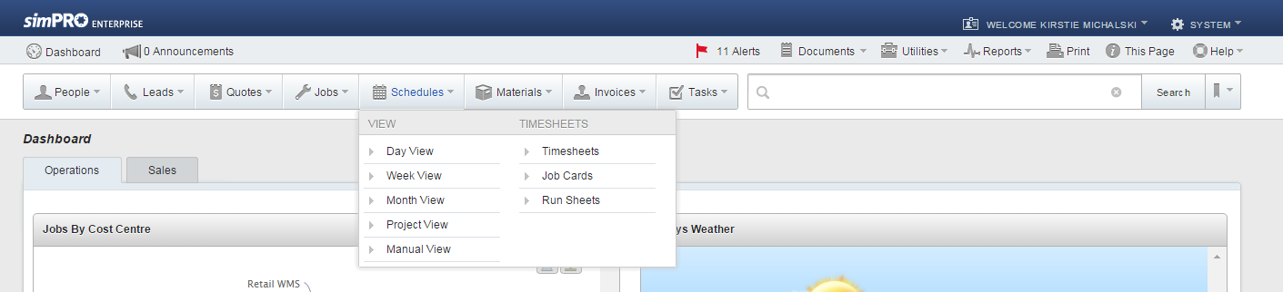

Step 2: Select the date range that you want the time sheet to be.
In the ‘Employees’ section, choose ‘select all’. Alternatively you can select each employee individually.
Leave the ‘display format’ tab as Visual. Change the ‘Schedule type’ to Job Cards. Click on ‘Submit’

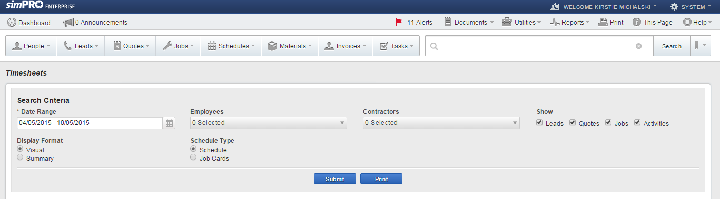

Once you have done this, you can print them all out.

Ordering
Thermotec provides air conditioning and refrigeration products to service the xxxx needs of customers. Thermotec products are synonymous with quality and exceeding customer expectations. These qualities must be maintained throughout the franchise network. In order to achieve this, THERMOTEC specifies which products you may sell in your franchise business. The approved products for sale are detailed in the approved products attachment. THERMOTEC may change the approved products list in order to improve the franchise network. THERMOTEC will notify of you in writing of the change and you then have 7 days to comply.

You are not required to sell or stock all approved products. THERMOTEC labels products into distinct categories which indicate the compulsory and optional offerings. Some products are central to the franchise offering and must be offered by all franchisees to maintain network consistency. Products are labelled into the following categories
- Core products – must be sold as they are critical to the franchise offer (attachment)
- Optional products – may or may not be sold by franchisees (attachment)

If you would like to discuss a product you believe should be added to the approved products list, please contact Thermotec head office as we will need to approve the stocking or selling of any product which is not listed.

Ordering products
All approved products must be purchased from approved suppliers. Franchise networks rely on a consistent product offering across sites, if any inconsistencies are caused, it potentially causes damage to the brand as well as other franchisees. Our products are synonymous with quality, and if this is compromised, customers will look to purchase elsewhere and the end result will hurt the entire network. One bad experience can be all it takes.
Our approved suppliers have shown to deliver quality products in a timely fashion. Thermotec’s buying power means it can attempt to negotiate favourable deals with suppliers. It is important you follow the product ordering process (attachment) and pay for goods in the agreed timeframe to maintain your relationship with suppliers. Particular attention must be paid to invoicing in order to understand the terms and make sure the correct amount is paid.
Build a good relationship with your suppliers by paying on time and constantly communicating. By developing a good relationship with suppliers you will continue to receive quality service and products. It is in your best interests to maintain this relationship as failing to do so potentially threaten the buying power of Thermotec and therefore could impact franchisee profitability

Ordering from alternative suppliers
Thermotec aims to negotiate favourable deals with suppliers that allow you to secure competitive rates for the quality of products available. In some circumstances, you may find an alternative supplier who offers a similar product which meets the quality standards the network sets. You must gain approved from Thermotec to purchase approved products from the alternative supplier. Contact Thermotec head office, and prepare a written statement which includes:
- Types of products on offer and evidence as to quality
- Pricing schedule and payment terms
- Contact details of the supplier
- Ability to service a larger network with the products on offer
- Amount of product to be purchased
- Evidence as to why you believe the product and supplier is consistent with Thermotecs network standards

Thermotec head office will then determine if the supplier qualifies for the approved supplier list.

Prices
Thermotec provides a recommended retail price for all approved products. You are free to charge above or below this price in your discretion. However, you must not charge more than the maximum price. When setting prices for products, it is important to remember:

- If you price your products too high, your volume and ultimately customers may decrease
- If franchisees price significantly differently, it can potentially cause internal network competition
- If your price is too low, you potentially significantly reduce your margins and profitability
- By pricing products low, you can potentially spark a competitive price war
- Low prices can lead to more sales, but you may have to increase other costs such as staffing to manage the increased volume. If the margin is too low, this can end up being counter productive

Obtaining Insurance
You must comply with the Insurance Contracts Acts (1984) when you engage your insurance company. This Act simply requires you to disclose every element that might be important to your insurance company accepting your insurance risk, as well as developing what terms are relevant.

Mandatory Insurance
The following types of insurance are compulsory for all applicable business:

Motor vehicles and fleets
It is compulsory to insure all company or business vehicles for third party injury liability. Many different types of policies are available, so make sure you understand the options before making a decision. There are four basic options:

Compulsory third party (injury)
- This policy covers you for claims made against you for personal injuries and legal costs arising from the use of your car. You must obtain this insurance to register your car.
Third party property damage
- This policy covers your liability for damage to another person or to the property of others and your legal costs. It doesn’t include repairs to your own car if you caused an accident.
Third party, fire and theft
- This policy covers you against the events covered above, as well as fire and theft. It also insures against damage caused if your car was stolen.
Comprehensive
- This policy covers you for all of the above plus damage caused to your own car by you in an accident. If you're buying a car on an instalment basis, financiers will usually insist on this cover.

You may be liable for damages or injuries to another person or property. Liability insurance is important as the likelihood of being sued for negligence is unpredictable and potentially very costly. Types of liability insurance you may need include:

Public Liability
- Public liability insurance protects you and your business against the financial risk of being found liable to a third party for death or injury, loss or damage of property or economic loss resulting from your negligence.
Professional Indemnity
- Professional indemnity insurance protects advice-based businesses from legal action taken for losses incurred as a result of professional negligence. It provides indemnity cover if your client suffers a loss - material, financial or physical - directly attributed to negligent acts, errors or omissions.
Product Liability
- If you sell, supply or deliver goods, even in the form of repair or service, you may need cover against claims of goods causing injury, death or damage. Product liability insurance covers you if any of these events happen to another business or person by the failure of your product or the product you are selling.

Other Insurances:
The following types of insurance are not compulsory, though it is recommended that you consider all options:

Building and contents
- Covers the building, contents and stock of your business against fire and other perils such as earthquake, lightning, storms, floods, impact, malicious damage and explosion.

Burglary
- Insures your business assets against burglary, and is most important for a retailer or business that has a property that is not always attended.
Business interruption or loss of profits
- Covers you if your business is interrupted through damage to property by fire or other insured perils. Ensures your ongoing expenses are met and profit is maintained through a provision of cash flow.
Deterioration of stock
- Covers your business for the deterioration of chilled, refrigerated or frozen stock following the breakdown of the refrigerator or freezer they were kept in.
Electronic equipment
- Covers your electronic equipment for theft, destruction or damage.
Employee dishonesty
- Covers losses resulting from employee theft or embezzlement.
Goods in transit
- Covers loss of, or damage to, the goods you buy, sell or use in your business when they are in transit by ship, air, post, rail or road.
Machinery breakdown
- Protects your business when mechanical and electrical plant and machinery at the worksite break down.
Tax Audit
- Covers you for the cost of professional fees in the event of a tax audit or investigation into your business.
Property in transit
- Covers theft or damage of items you use for business purposes that travel with you, such as tools and equipment.

You must provide written evidence of any insurance you take out for the franchise business

Workers Compensation
You must provide accident and sickness insurance for your employees (workers compensation) through an approved insurer. Workers compensation is covered by separate state and territory legislation. The aim of Workers compensation is to protect employees. However you should endeavour to minimise work related incidents. Your costs will be reduced if you can keep work accidents to a minimum, by providing a safe environment. Ensure you document everything carefully when and if an incident occurs. If there is a claim against you, please contact Thermotec Head Office immediately.

Personal accident and illness
If you are self-employed you won’t be covered by workers compensation, so it's recommended by law that you cover yourself for accident and sickness insurance through a private insurer. This policy will compensate you for loss of revenue while you or your employee(s) recover.
As a business owner, you may also wish to consider personal life insurance. There are several types of life insurance available. Some are investment-type funds where you contribute over a certain time and get back your investment plus interest earnings at the maturity date. Others are designed to cover things that could happen to you, such as:
- Income protection or disability insurance - covers part of your normal income if you are prevented from working through sickness or accident.
- Trauma insurance - provides a lump sum when you are diagnosed with one of several specified life threatening illnesses.
- Term life insurance or whole of life cover - provides your dependents with a lump sum if you die.
- Total and permanent disability insurance - provides a lump sum only if you are completely and permanently disabled before retirement.
There are many risks that your franchise business will face over the duration of your term. The minimum insurances are designed to protect you from many of these risks. However, there are some risks which may occur that Thermotec cannot predict. It is prudent to read and understand your insurance policies and levels of protection when you are selecting your insurance provider.

Licence Requirements
The following current licences, registrations and memberships are required prior to opening a Thermotec franchise. It is your responsibility to ensure these are maintained and renewed as appropriate.
- ARCtick Refrigerant Trading Authorisation (https://www.arctick.org/)
- Plumbing Industry Commission licence or relevant state licence
You will also require any other State or National Licences applicable to any works you will be conducting (i.e. Electrical Contractors Licence, Working at Heights).

Preparation of Reports
In order to appropriately review each franchisee, Thermotec requires the following reports to be prepared by you and your accountant.
- Profit & Loss Statement – Monthly
- Profit & Loss Annual Statement* - Annually
- Balance Sheet* – Annually
- Stocktakes – Annually
- Customer Feedback – Monthly
- Rostering Information (On Call) – Weekly
- Area Manager Evaluation Report – Monthly
- Business Plan – Annually
*These reports must contain an accountant’s certification that the data is true and correct.
If you fail to keep the appropriate records, as mentioned in the Franchise Agreement, Thermotec may organise an audit or facilitate action to generate the required reports (either through Thermotecs Head Office employees or a third party). Thermotec may coordinate an inspection of your records at any stage. You will be liable to pay for any action we have to take in order to obtain accurate records of performance.
All requested data will be delivered to the Thermotec Head Office in email and hard copy (mailed).

Cash Flow Budget
You should outline your expected cash inflows and outflows for each month, projected over an annual period. This will allow you to set targets and understand what cash will be required in order to meet your annual objectives. Take note of historical information for seasonality trends or peaks in expenditure for any given months.
When determining your cash flow budget, set up a monthly reporting tool which includes:

Month
Date
Accounts Receivable
Accounts Payable
Budget V Actual
Income
Gross Receipts - Budget | $ | $ | $ | $
Actual Income Received
Percentage | 0.00% | 0.00% | 0.00% | 0.00%
Invoicing
Gross Receipts - Budget | $ | $ | $ | $
Actual Invoiced Amount
Percentage | 0.00% | 0.00% | 0.00% | 0.00%
Profit & Loss - Cash
Income | $
Expenditure | $
Motor Vehicles - Leasing | $
Total | $ - | $ - | $ - | $ - | $ -

Once you have determined what variances exist from your forecasts, try to understand why this is the case and what you need to do to remedy the issue. For example, a higher spend in marketing may be required to increase sales, or tighter wastage control needed to reduce expenses. The trigger point for looking closer is when a higher variance % is achieved compared to your forecast.

Franchise Payments to Thermotec

Payment of Royalties
Thermotec will direct debit 14.5% of gross sales (excluding GST) weekly from your bank account as a royalty payment. This payment covers your right to trade under Thermotec’s brand and get access to our proven system. You must ensure this process functions by providing all appropriate information to Thermotec prior to starting your franchise business. Thermotec will provide you will a tax invoice indicating what has been paid as a royalty from your bank account.

Payment of Marketing Levies
Thermotec will direct debit 2% of gross sales (excluding GST) weekly from your account as a marketing levy payment. This payment will be received by a separate bank account and the monies will be spent on actively marketing the network, as per the activities mentioned in the Franchise Agreement.

Each year, Thermotec will follow its obligations under the Franchise Code of Conduct and have the account audited, with an annual statement provided within 3 months of the end of the financial year.

The marketing fund may be used to pay for:
- % of marketing employees
- Outsourced marketing resources
- Television advertising
- Radio advertising
- Internet advertising
- Brochures and catalogues (including their delivery)
- Newspaper advertising
- Sponsorship/Public Relations
- Developing and maintaining the customer loyalty program
- Product and customer research
- Maintaining and updating the Thermotec brand image
- Other marketing media

Payment for Other Services
Thermotec will assist you with your franchise business. This may involve us providing extra services such as training, financial reporting or seminars to help improve your business and your employees. As a result, you may have to pay for some of these services including:

- Training and seminar costs
- Costs of audit where discrepancy between your reported and actual revenue exceeds x%.
- Renewal fees
- Interest on payments
- Assignment fees

Some other, unexpected additional costs may also be applicable.

Payment for products
Upon delivery of goods from Thermotec, an accompanying invoice will be presented. Amounts owed to Thermotec for any products provided will be direct debited out of your account on a weekly basis.

Cleaning

Cleaning Agents
It is important that you clean on a regular basis to ensure your franchise business looks appealing and professional to customers. At a minimum, the following should be cleaned daily:

- Floors/Carpets/Tiles
- Bins should be cleaned and emptied
- All windows
- Counter or product serving areas
- Display areas
- Tables and chairs
- Vehicles & other company assets displaying the Thermotec Logo

Ongoing Cleaning
If you see a mess, it is best to clean it up straight away. This helps maintain the store throughout the day. Make sure you clean any spills or mess that could endanger customers or staff immediately.

Display Products
Having clean and presentable displays are important for selling products in a THERMOTEC franchise business. As customers are looking for a high quality products, they must be displayed in a fashion which best represents their features. Products must look fresh, cleanly presented and appealing to the customer. If you are selling food, steam should be appearing off hot products and the smell should attract customers. Jewellery for example, should be shining and draw the customer’s eye. Good displays are important for attracting customers and promoting the quality of your product.

Keys to making sure your product display is optimised include;
- Ensuring you have sufficient stock – when products start to get low, replenish them
- Clean spillages or product overflow as they occur
- Ensure glass displays are clean, well lit and products are visible
- Position your products accordingly, taking into account purchase volume and margins
- Ensure products are neatly displayed
- Ensure products look fresh and appealing
- Ensure all price tags or signs relating to product information are clearly visible and can be read by the customer
- Branded products should always be displayed neatly and checked to ensure sufficient numbers are available

Customer complaints
A customer complaint is a great opportunity to foster customer loyalty. Initially dissatisfied customers can be quickly turned into advocates for your business if they are handled effectively. This means dealing with customer problems, even if you are not at fault. Your staff will require the autonomy to handle customer complaints, so it is important to train them effectively. When dealing with customer complaints, you are advised to use the following process:
- Listen carefully to what the customer has to say, and let them finish. Don't get defensive. The customer is not attacking you personally; he or she has a problem and is upset. Repeat back what you are hearing to show that you have listened.
- Ask questions in a caring and concerned manner. The more information you can get from the customer, the better you will understand his or her perspective.
- Put yourself in their shoes. Your goal is to solve the problem, not argue. The customer needs to feel like you’re on his or her side and that you empathise with the situation.
- Apologise without blaming. When a customer senses that you are sincerely sorry, it usually diffuses the situation. Don't blame another person or department. Just say, "I'm sorry about that.”
- Ask the customer, "What would be an acceptable solution to you?" Whether or not the customer knows what a good solution would be, it’s best to propose one or more solutions to alleviate his or her pain. Become a partner with the customer in solving the problem.
- Solve the problem, or find someone who can solve it. Research indicates that customers prefer the person they are speaking with to instantly solve their problem. When complaints are moved up the chain of command, they become more expensive to handle and only add to the customer's frustration.
If you are unable to resolve the problem, please contact Thermotec Head Office for assistance

.

Abusive customers
Unfortunately, you may experience some customers who are abusive towards you or other staff members. Their behaviour is out of your control, but you must do everything in your power to diffuse the situation. It can be extremely difficult to handle these situations, but you should attempt to:

- Stay calm and speak slowly, being compassionate and understanding their anger
- Try to remove the customer from the store (if the behaviour is ridiculous and an act of them being drunk etc.)
- Try to encourage the customer away from other customers who may be intimidated
- Apologise to other customers
- Counsel the staff member who has been affected as they are likely to be upset over the experience

Serious Complaints
Some complaints may be extremely serious. In this case, it is crucial to keep carefully detailed notes of everything that occurs and all communication. You must always comply with your legal obligations mentioned on the website: www.consumer.gov.au
You must report serious complaints to the Thermotec Head Office. These include problems which relate to:
- Any poisoning or Food contamination claims
- Sexual harassment
- Occupational Health and Safety
- Criminal acts
- Any issue that may require police involvement

Business Security
You must take all appropriate actions to protect your business and assets. This involves complying with Thermotecs security equipment requirements (see Security Registers).

Theft
Many businesses can struggle with customer or staff theft. It is important you are able to minimise thievery as much as possible by taking all steps to limit your risk. Strategies to reduce theft include
- Install security cameras
- Avoid placing expensive items close to the exit
- Ensure the entire store is well lit
- Check employee references carefully prior to employment
- Set the tone from management and develop an honest culture
- Avoid staff serving their family members or friends
- Greet all customers and watch for odd behaviour
- Use strategic check-out areas
- Train employees to look for signs of theft

In the event you experience theft, make sure you document what was stolen, who may have been involved, the timeframe and what action was taken. Contact Thermotec Head Office in the event of any theft.

Customer Service
Maintaining a high level of customer service standards across the franchise network is crucial to Thermotec’s offering. You should follow the prevailing guidelines to ensure you deliver a consistently exceptional customer experience.

Consistent Trading Hours
- Customers like the certainty of knowing when a store will be open
- It is a good idea to stay open slightly after the scheduled day close in case a customer is running late

Efficient Customer Service
- Serve customers efficiently as possible
- If you are preoccupied with another customer, make sure you acknowledge the incoming customer and let them know you will be with them soon

Pleasing store aesthetics
- Ensure the store is clean and visually appealing
- Play approved music at a medium-low volume

Staff trained appropriately
- Ensure staff undertake continuous training to improve their customer service techniques
- Reward staff for delivering exceptional customer experiences

Manage, measure and improve
- Manage customer service standards, measure the outcomes and look at ways to improve

Customer Telephone Enquiries
Some of your franchise business customers will call to enquire about products or seek to order in advance, it is important that you and your staff have a good phone manner. Make sure you smile while you are dealing with customers as they can tell when you are not supportive of their interests. The following tips will help you communicate with customers on the phone:
- Answer with a smile and the standard response, which is outline below
- Speak slowly and clearly and in a friendly tone
- Try your best to be helpful
- Ensure you understand the important issues the customer wants solved
- Enquire deeper to ensure you understand all information
- Have a notepad handy so you can record important notes from the conversation

Standard telephone conduct
- Always answer the call as quickly as you can
- The standard answering line is “Good morning/afternoon/evening, Thermotec, Jeremy speaking”. Ask the customer how you can help them.
- Understand what the customer wants, and then solve the problem or organise for it to be solved. However, remember that transferring a customer to different departments where they have to re-explain their issue will make them more frustrated. Making sure you clearly understand the problem and putting them through the correct area is critical
- Show an interest in what the customer is telling you, make sure you are always friendly
- Ask them how their day is going, it is a good way to start building a relationship
- Deliver any messages to the required people and take responsibility over ensuring they resolve the issue
- Always complete the call with “is there anything else I can help you with”

Minimum Company Stock Requirements

You will be required to stock the below items prior to opening a Thermotec franchise.
Valves
Qty | Supplier | Cat # | Part No. | Description
1 | Actrol | 108057 | 068Z3284 | Danfoss TX Valve R22 Solder - Externally Equalized
1 | Actrol | 108045 | 068Z3385 | Danfoss TX Valve R134a Solder - Externally Equalized
1 | Actrol | 108056 | 068Z3415 | Danfoss TX Valve R404a Solder - Externally Equalized
1 | Actrol | 108021 |  | 01 Orifice - Danfoss
 | Actrol | 108022 |  | 02 Orifice - Danfoss
 | Actrol | 108023 |  | 03 Orifice - Danfoss
 | Actrol | 108024 |  | 04 Orifice - Danfoss
 | Actrol | 108025 |  | 05 Orifice - Danfoss
 | Actrol | 108026 |  | 06 Orifice - Danfoss
 |  |  |  | Note: Alternative Valves and smaller Orifices can be
 |  |  |  | ordered on an as required basis - this list will cover
 |  |  |  | most commercial capacities.
1 | Actrol | 197290 |  | Teflon Seal Ring Multi Pack (Rotalock)
5 | Actrol | 207088 |  | 1/4 Schrader Access Valve
2 | Actrol | 207156 |  | Multi Size Access Valve
1 | Actrol | 198021 |  | Bullet Line Piercing Valve
1 | Actrol | 123046 |  | 240v Castel Solenoid Coil
1 | Actrol | 123073 |  | Castell Junction Box
1 | Actrol | 122067 |  | Danfoss 240v Solenoid Coil
Controls
Qty | Supplier | Cat # | Part No. | Description
1 | Actrol | 147028 |  | Ranco Dual Pressure Control
1 | Actrol | 147001 |  | Ranco Low Pressure Control
1 | Actrol | 144094 |  | Penn Thermostat
1 | Actrol | 147038 |  | Cover Replacement for Ranco 016
1 | Actrol | 147039 |  | Cover Replacement for Ranco 017
1 | Actrol | 148002 |  | Ranco Thermostat
1 | Actrol | 146272 |  | Carel Probe NTC
1 | Actrol | 144201 |  | Phasefale Sensor
Driers
Qty | Supplier | Cat # | Part No. | Description
2 | Actrol | 169013 |  | High Cap Black POE
1 | Actrol | 171002 |  | 1/4 Flare 032 Drier
1 | Actrol | 171006 |  | 3/8 Flare 032 Drier
1 | Actrol | 171003 |  | 1/4 Solder 032 Drier
1 | Actrol | 171076 |  | 3/8 Flare 083 Drier
1 | Actrol | 171023 |  | 1/2 Flare 164 Drier
1 | Actrol | 171025 |  | 5/8 Flare 165 Drier
Oils and Consumables
Qty | Supplier | Cat # | Part No. | Description
1 | Actrol | 184039 |  | Acid Test Kit - Mineral Oil
1 | Actrol | 184059 |  | Acid Test Kit - Polyester Oil
1 | Actrol | 184409 |  | Leak Detector Solution
1 | Actrol | 184120 |  | B5 Oil - 4 Litre
1 | Actrol | 184133 |  | BSE 32 Oil - 5 Litre
1 | Actrol | 184023 |  | Vac Pump Oil - 4 Litre
1 | Actrol | 184135 |  | Flushing Agent - 5 Litre
1 | Actrol | 184431 |  | Spill Kit
Fittings
Qty | Supplier | Cat # | Part No. | Description
1 (5) | Actrol | 190060 |  | 1/4" Brass SB Flare Nut 5 Pack
1 (5) | Actrol | 190062 |  | 3/8" Brass SB Flare Nut 5 Pack
2 (2) | Actrol | 190064 |  | 1/2" Brass SB Flare Nut 2 Pack
2 (2) | Actrol | 190066 |  | 5/8" Brass SB Flare Nut 2 Pack
1 (2) | Actrol | 190068 |  | 3/4" Brass SB Flare Nut 2 Pack
1 (5) | Actrol | 190200 |  | 1/4" Flare Bonnet 5 Pack
1 (10) | Actrol | 190210 |  | 1/4" Flare Copper Washer 10 Pack
1 (10) | Actrol | 190211 |  | 3/8" Flare Copper Washer 10 Pack
2 | Actrol | 191017 |  | 1/4 MF x 3/8 FMF Brass Union
2 | Actrol | 191024 |  | 3/8 MF x 3/8 FMF Brass Union
1 | Actrol | 191125 |  | 1/4 MF x 1/8 BSP Brass Union
1 | Actrol | 191127 |  | 1/4 MF x 1/4 BSP Brass Union
1 | Actrol | 191137 |  | 3/8 MF x 1/4 BSP Brass Union
1 | Actrol | 194082 |  | Brass Tee: 1/4 MF 1/8 BSP Branch
1 | Actrol | 201307 |  | 5/8 Copper Elbow 3 Pack
1 | Actrol | 201308 |  | 3/4 Copper Elbow 3 Pack
1 | Actrol | 201309 |  | 7/8 Copper Elbow 3 Pack
1 | Actrol | 201310 |  | 1" Copper Elbow 2 Pack
1 | Actrol | 201311 |  | 1 1/8 Copper Elbow 2 Pack
1 | Actrol | 201313 |  | 1 3/8 Copper Elbow 2 Pack
1 | Actrol | 201315 |  | 1 5/8 Copper Elbow 2 Pack

This can be ordered as a Thermotec Starter pack. The current price is $..... Which may vary?

SECTION 5 – MARKETING

Marketing Activities
It is important that you undertake marketing activities in order to grow your business and constantly communicate with your customers. People are more likely to purchase from you if the Thermotec business is at the forefront of their minds during their decision making process. In order for your Thermotec franchise to be top of mind, you must create and implement a marketing plan (attachment) which will include:
- Target market
- Marketing budget
- Activities undertaken (including timeframe and who is responsible)
- Cost per activity
- Measurement tools and return on investment

You will be required to complete a marketing plan each year for your franchise business. An important element of this is discussing each of the activities you will undertake. Some of these may include:
- Local event or sporting club sponsorship
- Community networking events
- Local radio or newspaper advertising
- Online advertising (talk with Thermotec Head Office about this)
- Social media marketing (talk with Thermotec Head Office about this)
- Letter box drops (brochures or specials)
- Gift promotions
- Loyalty programs
- Printed brochures and written materials
By closely reviewing how each marketing activity performs, you can use this as a guide for preparing future budgets and expected returns. Thermotec Head Office will provide you with a sample marketing budget template to assist you (attachment).

It is a good idea to identify what marketing activities competitors are undertaking and observing if they are being successful (an opportunity may arise for you to run a similar marketing activity. Try to stick to your marketing budget and focus on activities that provide the great return on investment)

To assist you with your initial local area marketing campaign, Thermotec Head Office will supply you with approved templates and materials.

Marketing Approval
Every marketing initiative you undertake must be approved by the Thermotec Head Office. We will provide you with many materials that you may use in your marketing efforts that have already been approved by us. Samples of pre-approved materials are included in the attachment (attachment).
It is important Thermotec Head office approves all marketing materials to ensure the brand is being represented appropriately and to guide you on how they will help grow your franchise business. For example, our experience from previous marketing trials should enable you to focus your activities on areas that have proven to be successful, versus those that have failed to achieve reasonable returns in the past.

How do you get marketing approval?
Prior to committing to any suppliers, you must send Thermotec Head Office detail regarding the planned marketing activity. This must include specific information about:
- Why you are doing the marketing activity (what is it intended to achieve)
- What the intended marketing activity is and its roll out plan (timeframe)
- Details of the supplier you intend to use and whether they are capable of servicing the entire network
- What costs are involved with the marketing activity are
- What results is the marketing activity expected to yield and how they will be measured
Thermotec Head Office will then discuss whether the intended marketing activity will be approved or not and you will be contacted as appropriate.

Brand Values
When you are intending to undertake any marketing activity, you should carefully consider what values the brand holds. The Thermotec brand is synonymous with the following characteristics and it is important you maintain these standards

- Product quality
- Service quality
- Efficiency of service
- Cost leadership

Brand values will dictate the experience our customers expect from us. For example, Virgin customers expect a friendly, but fun loving service experience when they fly. Qantas customers expect a professional and prestige flying experience. It is important you consistently adhere to the Thermotec brand standards

Brand Imagery

Logo
Our logo has been designed to represent the values that are important to the brand (as mentioned above). Ideally, our customers will recognise our logo and intuitively relate it with the brand values we hold and a positive experience. In order to build and project this image to customers, you must present the logo in a high quality format. For example, if the signage outside is dirty, it immediately reflects an unclean image for the entire store. This is why whenever you are using any materials (uniforms, brochures, letters) or structures (signage) with relation to the logo, it is critical it is displayed with:

- 16:4 ratio
- RED COLOUR 1235
- BLUE COLOUR 4324
- BLACK COLOUR 4543

Font
If at any stage you are preparing documentation or a letter, you should follow the font guidelines listed below:
Email or letter
- Font size – 11 pt.
- Font type – Arial
- Bullet types – or dot
- Heading 1
- Heading 2
- Heading 3
- Standard email colours
- Standard signature

Other documentation
- Font size – 11 pt.
- Font type – Arial
- Bullet types – or dot
- Heading 1
- Heading 2
- Heading 3
- Standard email colours

Company Vehicles
The appearance of your vehicle is often the first impression our Client gains of your business, therefore let it be a good lasting one.
You only have one chance to make a good, first impression.
Your vehicle used in your business should be in good working order, be roadworthy and be fully registered and insured.
All vehicles are to carry the signs authorised by Thermotec;
Thermotec will provide vehicle signage design/templete for vehicle. You will need to arrange the vehicle signage application at your own cost.
Vehicles are to be kept as tidy and clean as possible.
Any panel defects (rust or accident damage) must be reported to Head Office & repaired promptly.
No additional signage / stickers are to be displayed on the vehicle without written permission from Thermotec head office.
Vehicle signage must be commercially produced in accordance with our company rules.
You will need to adhere to road rules and do not break the law.
Make certain only you and your team with the correct class of current driver’s license are permitted to drive.
Company vehicles and all drivers and license details are reported to the insurance company.

APPENDIX
- Approved Supplier List
- Minimum Company Stock Requirements
- Staff Starter Pack
  - Employee Details Form
  - Company Rules
  - Thermotec Vehicle Use
  - Employee Induction
  - Fair Work
  - Tax File Number Declaration
- Performance agreement templete
- Area Manager evaluation templete
- Phone Diversion Plan
- Key Register
- Hazard Report Form
- Injury/Incident Report
- RICE Principal
- DRSABCD Principal
- Application for Leave form
- Employee warning notice
- Thermotec meeting minutes templete
- Payroll deduction authorisation form
- Creating a job on SimPRO
- Creating a purchase order on SimPRO
- Creating a quote on SimPRO
- How to use Connect app for tablet
- Example phone message memo
- Alarm access code register
- iPad register
- Vehicle register
- Phone register
- Passwords register templete
- Parts inventory templete
- Customer feedback form
- Plant & equipment register
- Technical Support

Approved Supplier List
Supplier | Products
Actrol Parts | Air Conditioning Components, Air Conditioning Units, Refrigeration Components
Air Diffusion | Air Conditioning Components, Air Conditioning Units
Airefrig | Air Conditioning Components
Andale Beverage Systems | Beer Dispensing Equipment
Austcoil Pty Ltd | Coils
Austral Refrigeration (Hussmann) | Coolroom Components
Austwide Plastics | Gaskets
Bitzer Australia | Refrigeration Components
BOC | Gas
CRH Australia | Coolroom parts (Hinges, legs etc.)
Fantech Pty Ltd | Fans
Hevac Control Agencies | Air Conditioning Controls
J L Lennard | Postmix parts, Soft Service Machine parts (McDonalds, Hungry Jacks)
Pacific HVAC | Air Conditioning Components
Reece | Plumbing Parts
Temperzone | Air Conditioning Components, Air Conditioning Units
Totaline Parts | Air Conditioning Components

Minimum Company Stock Requirements
Valves
Qty | Supplier |  | Cat # |  | Part No. | Description
1 | Actrol |  | 108057 |  | 068Z3284 | Danfoss TX Valve R22 Solder - Externally Equalized
1 | Actrol |  | 108045 |  | 068Z3385 | Danfoss TX Valve R134a Solder - Externally Equalized
1 | Actrol |  | 108056 |  | 068Z3415 | Danfoss TX Valve R404a Solder - Externally Equalized
1 | Actrol |  | 108021 |  |  | 01 Orifice - Danfoss
 | Actrol |  | 108022 |  |  | 02 Orifice - Danfoss
 | Actrol |  | 108023 |  |  | 03 Orifice - Danfoss
 | Actrol |  | 108024 |  |  | 04 Orifice - Danfoss
 | Actrol |  | 108025 |  |  | 05 Orifice - Danfoss
 | Actrol |  | 108026 |  |  | 06 Orifice - Danfoss
 |  |  |  |  |  | Note: Alternative Valves and smaller Orifices can be
 |  |  |  |  |  | ordered on an as required basis - this list will cover
 |  |  |  |  |  | most commercial capacities.
1 | Actrol |  | 197290 |  |  | Teflon Seal Ring Multi Pack (Rotalock)
5 | Actrol |  | 207088 |  |  | 1/4 Schrader Access Valve
2 | Actrol |  | 207156 |  |  | Multi Size Access Valve
1 | Actrol |  | 198021 |  |  | Bullet Line Piercing Valve
1 | Actrol |  | 123046 |  |  | 240v Castel Solenoid Coil
1 | Actrol |  | 123073 |  |  | Castell Junction Box
1 | Actrol |  | 122067 |  |  | Danfoss 240v Solenoid Coil
Controls
Qty | Supplier |  | Cat # |  | Part No. | Description
1 | Actrol |  | 147028 |  |  | Ranco Dual Pressure Control
1 | Actrol |  | 147001 |  |  | Ranco Low Pressure Control
1 | Actrol |  | 144094 |  |  | Penn Thermostat
1 | Actrol |  | 147038 |  |  | Cover Replacement for Ranco 016
1 | Actrol |  | 147039 |  |  | Cover Replacement for Ranco 017
1 | Actrol |  | 148002 |  |  | Ranco Thermostat
1 | Actrol |  | 146272 |  |  | Carel Probe NTC
1 | Actrol |  | 144201 |  |  | Phasefale Sensor
Driers
Qty | Supplier |  | Cat # |  | Part No. | Description
2 | Actrol |  | 169013 |  |  | High Cap Black POE
1 | Actrol |  | 171002 |  |  | 1/4 Flare 032 Drier
1 | Actrol |  | 171006 |  |  | 3/8 Flare 032 Drier
1 | Actrol |  | 171003 |  |  | 1/4 Solder 032 Drier
1 | Actrol |  | 171076 |  |  | 3/8 Flare 083 Drier
1 | Actrol |  | 171023 |  |  | 1/2 Flare 164 Drier
1 | Actrol |  | 171025 |  |  | 5/8 Flare 165 Drier
Oils and Consumables
Qty |  | Supplier |  | Cat # | Part No. | Description
1 |  | Actrol |  | 184039 |  | Acid Test Kit - Mineral Oil
1 |  | Actrol |  | 184059 |  | Acid Test Kit - Polyester Oil
1 |  | Actrol |  | 184409 |  | Leak Detector Solution
1 |  | Actrol |  | 184120 |  | B5 Oil - 4 Litre
1 |  | Actrol |  | 184133 |  | BSE 32 Oil - 5 Litre
1 |  | Actrol |  | 184023 |  | Vac Pump Oil - 4 Litre
1 |  | Actrol |  | 184135 |  | Flushing Agent - 5 Litre
1 |  | Actrol |  | 184431 |  | Spill Kit
Fittings
Qty |  | Supplier |  | Cat # | Part No. | Description
1 (5) |  | Actrol |  | 190060 |  | 1/4" Brass SB Flare Nut 5 Pack
1 (5) |  | Actrol |  | 190062 |  | 3/8" Brass SB Flare Nut 5 Pack
2 (2) |  | Actrol |  | 190064 |  | 1/2" Brass SB Flare Nut 2 Pack
2 (2) |  | Actrol |  | 190066 |  | 5/8" Brass SB Flare Nut 2 Pack
1 (2) |  | Actrol |  | 190068 |  | 3/4" Brass SB Flare Nut 2 Pack
1 (5) |  | Actrol |  | 190200 |  | 1/4" Flare Bonnet 5 Pack
1 (10) |  | Actrol |  | 190210 |  | 1/4" Flare Copper Washer 10 Pack
1 (10) |  | Actrol |  | 190211 |  | 3/8" Flare Copper Washer 10 Pack
2 |  | Actrol |  | 191017 |  | 1/4 MF x 3/8 FMF Brass Union
2 |  | Actrol |  | 191024 |  | 3/8 MF x 3/8 FMF Brass Union
1 |  | Actrol |  | 191125 |  | 1/4 MF x 1/8 BSP Brass Union
1 |  | Actrol |  | 191127 |  | 1/4 MF x 1/4 BSP Brass Union
1 |  | Actrol |  | 191137 |  | 3/8 MF x 1/4 BSP Brass Union
1 |  | Actrol |  | 194082 |  | Brass Tee: 1/4 MF 1/8 BSP Branch
1 |  | Actrol |  | 201307 |  | 5/8 Copper Elbow 3 Pack
1 |  | Actrol |  | 201308 |  | 3/4 Copper Elbow 3 Pack
1 |  | Actrol |  | 201309 |  | 7/8 Copper Elbow 3 Pack
1 |  | Actrol |  | 201310 |  | 1" Copper Elbow 2 Pack
1 |  | Actrol |  | 201311 |  | 1 1/8 Copper Elbow 2 Pack
1 |  | Actrol |  | 201313 |  | 1 3/8 Copper Elbow 2 Pack
1 |  | Actrol |  | 201315 |  | 1 5/8 Copper Elbow 2 Pack

Staff Starter Pack

3.1 Employee Details Form

Employee Details Form

First Name: ____________________ Last Name: _______________________

Start Date: _____ /_____ /_____

Position Title: __________________ Date of Birth: ____/___/___

Work mobile: ________________ Private Mobile: _______________

Home phone: ________________

Email address: ____________________________________

Residential address: _____________________________________
______________________________________________________

Postal address: _________________________________________

Emergency contact 1- Name: _________________________
Phone: ________________________
Mobile: ________________________
Emergency contact 2- Name: _________________________
Phone: ________________________
Mobile: ________________________

Bank Details

Bank: Name: __________________________ Branch: ________________________________

Account Name: ________________________________________________________________

BSB: - Account Number

Employee Tax File:

Superannuation Details

Super Fund: ______________________________________
Member No: ______________________________________

License Numbers

Work vehicle rego: _____ - _____
Driver’s license and expiry: _____________________________
ARCtick license and expiry: _____________________________
Plumbing license and expiry: ___________________________
Electrical license and expiry: ___________________________
Site induction card: __________________________
Fork lift license and expiry: _____________________________
Any other license numbers and expiries: _________________________________
_______________________________________________________
_______________________________________________________
_______________________________________________________

Company Details

Company Name: Thermotec Group Pty Ltd

Company Address: 272 Etiwanda Ave, Mildura

Company Phone Number: (03) 5022 1671 Company email: Sales@thermotecgroup.com.au

Employee Signature: ________________________ Date: _____ /_____ /______

Manager’s Signature: _______________________ Date: _____ /_____ /______

Company Rules
COMPANY RULES

- ANY INFORMATION RECEIVED IN THE WORKPLACE MARKED CONFIDENTIAL IS NOT TO BE REMOVED FROM THE WORKPLACE, GIVEN, OR TRANSMITTED IN ANY FORM TO ANY OTHER FROM OUTSIDE THE WORKPLACE

- REMOVAL OF ANY MATERIALS, EQUIPMENT, TOOLS, CHEMICALS, FUEL OR ANY OTHER ITEM FROM THE PROPERTY WITHOUT WRITTEN AUTHORISATION FROM THE MANAGER IS AN ILLEGAL ACT AND SHALL BE DEALT WITH ACCORDINGLY.

- NO ALCOHOL OR DRUGS - STAFF ARE NOT PERMITTED TO USE OR BE UNDER
THE INFLUENCE OF ALCOHOL OR DRUGS WHILST AT WORK ON THE PREMISIS,ON ANY WORK SITE, DRIVING VEHICILES OR OPERATING EQUIPMENT.(SEE THERMOTEC CONDITIONS OF VEHICILE USE FOR MORE DETAIL)

- EMPLOYEES SHALL NOT DO ANYTHING TO PUT AT RISK OR ENDANGER THEM SELVES OR
ANY OTHER PERSON.

- USE OF CHEMICALS IS ONLY TO BE UNDERTAKEN AFTER AUTHORISATION
AND INSTRUCTION FROM THE MANAGER.

- DO NOT USE ANY VEHICLE, PLANT OR EQUIPMENT WITHOUT PRIOR AUTHORISATION FROM THE MANAGER AND AFTER THE MANAGER HAVING CITED (AND COPIED FOR
OFFICE RECORDS) ANY RELEVANT LICENCE / PERMIT REQUIRED TO OPERATE SUCH VEHICLE, PLANT OR EQUIPMENT.

- MANAGER IS TO ENSURE SUFFICIENT OPERATING INSTRUCTIONS ARE GIVEN TO THE
OPERATOR TO OPERATE THE PARTICULAR VEHICLE, PLANT OR EQUIPMENT IN A COMPETENT MANNER.

- DO NOT REMOVE UNREGISTERED VEHICLES OR TRAILERS FROM PROPERTY

- NOTIFY THE MANAGER OF ANY VEHICLE, PLANT, EQUIPMENT OR IMPROVEMENT
THAT IS FAULTY OR REQUIRES MAINTENANCE / REPAIRS. DO NOT
USE OR CONTINUE TO USE THESE ITEM/S UNTIL THE FAULT IS REPAIRED OR REPLACED.

- IF MACHINERY OR EQUIPMENT IS TAGGED OUT IT IS NOT TO BE USED NOR IS THE TAG TO BE REMOVED

- DO NOT REMOVE GUARDS FROM PLANT / EQUIPMENT.

- KEEP WORK AREA CLEAN - PLACE ALL RUBBISH IN BINS PROVIDED OR TAKE IT WITH YOU.

- IF YOU ARE UNSURE OF ANY DIRECTIVES GIVEN BY THE MANAGER, OR UNCERTAIN OF
ANYTHING ELSE THEN PLEASE ASK THE MANAGER TO CLARIFY THE ISSUE.

- INFORM THE MANAGER OF ANYTHING WHICH MIGHT CAUSE AN INJURY OR AN
ACCIDENT.

- REPORT ANY INJURY IMMEDIATELY TO THE MANAGER.

- ALWAYS USE SAFE MANUAL HANDLING PROCEDURES WHEN MANUALLY HANDLING ITEMS.

- STURDY, NON-SLIP SAFETY FOOTWEAR SHOULD ALWAYS BE WORN, PARTICULARLY NO THONGS / SANDALS ALLOWED.

- LONG HAIR SHOULD BE TIED BACK WHEN WORKING AROUND PLANT AND EQUIPMENT.

- A FIRST AID KIT IS LOCATED IN THE MEALS BREAK ROOM. CONSULT THE MANAGER FOR ITS USE.

- NO PANADOL OR OTHER SIMILAR MEDICATIONS ARE AVAILABLE FROM THIS WORK PLACE - YOU ARE TO SUPPLY YOUR OWN REQUIREMENTS AS DIRECTED BY A MEDICAL PROFESSIONAL.

- PERSONAL HYGIENE IS IMPORTANT, STAFF SHOULD MAINTAIN A HIGH STANDARD TO ENSURE OUR WORK SITE IS FREE OF INFECTIOUS DISEASES (WASH HANDS AFTER GOING TO THE TOILET)

- IN THE INTREST OF OUR EMPLOYEES, WE ENCOURAGE STAFF WITH INFECTIOUS DISEASES OR MEDICAL CONDITIONS THAT REQUIRE SPECIAL TREATMENT TO NOTIFY THE MANAGER SO THAT APPROPRIATE FIRST AID WILL BE AVAILABLE IF REQUIRED

- PERSONAL PROTECTION EQUIPMENT (PPE) IS PROVIDED BY THE COMPANY, PLEASE ENSURE YOU USE IT AT ALL TIMES. THIS INCLUDES EYE, HAND, HEARING & SUN PROTECTION

- STAFF ARE NOT PERMITTED TO BRING NON EMPLOYEES TO THE WORKPLACE WITHOUT PREVIOUS AGREEMENT BY THE MANAGER

- WILLFULL DAMAGE TO COMPANY EQUIPMENT, PPE OR DELIBERATE DISREGARD OF ANY SAFE PRACTICES OR PROCEDURE WILL RESULT IN INSTANT DISMISSAL

- STAFF ARE EXPECTED TO REPORT FOR WORK AND LEAVE THE WORKPLACE AT THE TIMES SPECIFIED BY THE COMPANY

- MOBILE PHONES ARE NOT TO BE USED WHEN FUELING, DRIVING VEHICLES OR PERFORMING ANY OTHER ACTIVITY OR IN ANY OTHER PLACE WHERE MOBILE PHONE USE IS ILLEGAL.

- SMOKING IN BUILDINGS, VEHICLES OR WHEN OPERATING MACHINERY OR PLANT IS NOT PERMITTED.

I have received a comprehensive induction into Thermotec Group, I have been informed of and understand the Safe Work Policy and Procedures of Thermotec Group and agree to abide by the Policy and Company Rules as set out above

Employees Name……………………………………………………………..

Employees Signature…………………………………………………………

Date……./……/……….

THERMOTECFOSTERS A POSITIVE, NON POLITICAL, HEALTHY WORK ENVIRONMENT, WE ENCOURAGE FRIENDLY CO-OPERATIVE WORKING RELATIONSHIPS BETWEEN ALL STAFF MEMBERS AND VERY MUCH SUPPORT A PROACTIVE TEAMWORK PHILOSOPHY

We hope you enjoy our safe and friendly work site

Thermotec Vehicle Use
Conditions of use of Thermotec Group Pty Ltd Vehicles

I agree to the following conditions and requirements for the use and maintenance of the work vehicles provided to me by Thermotec Group Pty. Ltd.

- Vehicles are to be kept in a neat, tidy and clean condition inside and out at all times.

- Vehicles are to be serviced every 10,000km. This is the driver’s responsibility to ensure this is booked via the office, 500km prior to being due.

- Vehicles are provided for work purposes. Any private use is to be pre-arranged and kept to a minimum. If required for private use this must be organized with management.

- Under no circumstances are Thermotec Vehicles to be driven if over the legal blood alcohol limit or under the influence of any illegal or prescription drugs. Any damage caused by this act will be the responsibility of the driver and they may be liable to pay all cost relating.

- Vehicles are not to be driven by non-Thermotec staff unless prior arrangement has been made with management.

- Cleaning of vehicle is to be done in the staff members own time (as is standard procedure for all tradesmen) on a minimum weekly basis or as requested by management.

- If vehicle is required to be cleaned as part of job (ie.mud from mine site) this can be done in work hours and booked to that job.

- If the vehicle requires anything replaced (ie.tyres, batteries, seat covers etc.) There must be prior arrangement and an order made from the office.

- Any damage incurred to the vehicle must be reported immediately and repaired as soon as possible.

- Vehicles damaged during private use the driver of that vehicle maybe required to pay an excess plus out of pocket expense incurred by Thermotec.

- The drivers of any Thermotec Vehicles are liable for any speeding, parking or any other infringement that they would normally be responsible for.

- Cell phones or any other technology/applications are not permitted (both company and privately owned) either handheld or hands-free, while operating a motor vehicle on company business, on site and/or on operating a motor vehicle on company time.

- It is the franchisees responsibility to ensure any Thermotec branded vehicle is driven in a responsible, courteous & law abiding manner

Any failure to adhere to these rules will result in vehicles only being able to be driven during working hours and kept at workshop. Please remember that Thermotec vehicles are a vital part of our company’s tools and need to be kept in the best condition possible.

This is a legally binding contract.

Signed ____________________ Signed______________________
Daryell Scase

Employee Induction

Employee Induction
Location …………………………. Date…../……/…….
Person Responsible for Induction……………………....
Person Inducted………………………………………….
Position …………………………………………………..

Part 1 Administration:
 | Yes | No | NA
Pre placement Medical Completed (if applicable)

Forms
- Payroll Form
- Employee Declaration (Tax)
- Banking details (for wage payments)

Copies of Licenses / Certificates taken

Mobile equipment, Forklift, Truck etc.

First Aid

Other

General Information
Overview of Company (what the company does)
Pay Arrangements and deduction facilities
Hours of Work
Shift Arrangements
Reporting Structure
Overtime
Sick Leave & absence notification
Annual Leave
Bereavement Leave
Probationary Period
Lunch & Tea Breaks
Superannuation
General Policies and Procedures | Yes  Tick | No  Tick | NA  Tick
Attendance and punctuality hours of work
Disciplinary procedures
Grievance Resolution Procedures
Telephone Usage, mobile & company phone
Standards Of Dress

OHS Policies and Procedures
Company Safety Plan
Alcohol and Drugs
Reporting Hazards
Harassment / workplace bullying policy
Environmental / smoking policy
Personal Protective Equipment policy Use, storage, maintenance
Emergency Evacuation procedure / assembly area
Plant & Equipment general procedures / guarding policy
Manual Handling Policy
- Use of mechanical lifting devices
- Safe lifting explained
Hazardous Substances explained
- Availability of MSDS
- Using hazardous substances
Housekeeping
- Keeping area clean ( clean up as you go )
- Rubbish in bins
- Spills to be cleaned up
- Tools and equipment to be put away after use
First Aid Provisions
- Workers Compensation Requirements
- Completion of Register of Injuries
- Making a workers compensation claim
- Return to work provisions

Part 2 To be completed by Immediate Supervisor

 | Yes | No | NA

Explanation of Supervisors Role

Site Tour
Personal Storage of belongings
Amenities
Lunch room & where to obtain food
Location of first aid kits
Hazardous Work Areas (Dangerous goods etc.)
Emergency evacuation procedure explained

Emergency assembly area identified
Safety Signs (must be followed)

Introductions
Safety Committee / OHS representatives
Union representative (if applicable)
Work mates
Issue of personal protective equipment & explanation of use
- List Items: ear muffs, eye protection, hi vis clothing, safety boots
On the job training
  - Operating plant only when competent & authorized
- Explanation of all safe working procedures
- List procedures

I have received a comprehensive induction into Thermotec Group, I have been informed of and understand the Safe Work Policy and Procedures of Thermotec Group and agree to abide by the Policy and Company Rules as set out above, I also declare that I do not have any pre-existing health issues that may impede or stop me performing the duties which I have been employed for.

Name of New Employee………………………………………

Signature………………………………………………… Date of Signature……………………

Name of Supervisor…………………………………………….
Signature…………………………………………………… Date of Signature…………………….

Fair Work Information Statement
Please visit: http://www.fairwork.gov.au/employee-entitlements/national-employment-standards/fair-work-information-statement

Tax File Number Declaration
You can obtain a paper copy of the Tax File Number Declaration (NAT 3092) including both the instructions and form by phoning 1300 720 092 or from most newsagents and post offices.

Performance agreement templete
Performance agreement
To be completed with the employee during the initial performance discussion meeting.
Areas for Development | Actions
<Enter details of the skills and behaviors the employee would like to improve. This may be to improve outcomes or to develop new skills for future career goals.> | <List agreed strategies to achieve the development>
For example – Improve customer service skills so that I can handle complex enquiries. | e.g. coaching, on-the-job training, external training
Performance agreement approval
Employer Signature: | Employee Signature:
Print Name: | Print Name:
Date: | Date:

Area Manager evaluation report
Manager |  | Review By
Name: |  | Name:
Position: |  | Position:
Time Period of Review |  | Date of Review:
From: To: |  | Review Due Date:
Definition of Performance Level Ratings
1 = Far exceeds job standards and expectations
2 = Consistently exceeds job standards and expectations
3 = Meets the job standards and expectations
4 = Sometimes meets the job standards and expectations
5 = Overall work does not meet the minimum job standards
Job Skills & Knowledge | Performance Level | Comments
Has practical, technical and professional skills required for the job | 1 2 3 4 5
Has sufficient knowledge and experience of all aspects of business operations to make informed decisions within the scope of responsibility | 1 2 3 4 5
Keeps up to date with best practices and new developments | 1 2 3 4 5
Ensures hiring and training procedures, including EEO, are followed | 1 2 3 4 5
Ensures safety and security practices and procedures are followed | 1 2 3 4 5
Strengths
Goals
 |  | Overall Rating
 |  | 1 2 3 4 5
Planning & Organisation | Performance Level | Comments
Sets precise, measurable goals that are realistic, challenging and compatible with company goals | 1 2 3 4 5
Manages time effectively | 1 2 3 4 5
Anticipates problems and plans accordingly; acts versus reacts | 1 2 3 4 5
Delegates responsibility appropriately | 1 2 3 4 5
Able to prioritize work. Sets realistic deadlines for self and others and ensures deadlines are met | 1 2 3 4 5
Strengths
Goals
 |  | Overall Rating
 |  | 1 2 3 4 5
Budget Administration | Performance Level | Comments
Ability to develop, manage and critique budget | 1 2 3 4 5
Utilizes forecasting in planning, staffing and cost control | 1 2 3 4 5
Assumes leadership for increasing sales in own area and with others | 1 2 3 4 5
Identifies and implements cost reduction measures without detracting from service, operational or quality level | 1 2 3 4 5
Observes early signs of changing conditions; responds effectively | 1 2 3 4 5
Strengths
Goals
 |  | Overall Rating
 |  | 1 2 3 4 5
Training & Development | Performance Level | Comments
Ensures new employees are fully trained on all aspects of the job | 1 2 3 4 5
Provides clear, objective and timely feedback to employees | 1 2 3 4 5
Identifies promotable employees and provides necessary training | 1 2 3 4 5
Follows up and integrates training received | 1 2 3 4 5
Takes responsibility for his/her own training and development | 1 2 3 4 5
Strengths
Goals
 |  | Overall Rating
 |  | 1 2 3 4 5
Problem Solving | Performance Level | Comments
Observes early signs of changing conditions | 1 2 3 4 5
Offers creative and effective solutions | 1 2 3 4 5
Uses all available and appropriate resources, including employees | 1 2 3 4 5
Follows up to ensure that appropriate actions have been taken | 1 2 3 4 5
Open to new ideas, allows and supports employees to make decisions | 1 2 3 4 5
Strengths
Goals
 |  | Overall Rating
 |  | 1 2 3 4 5
Communications | Performance Level | Comments
Presents ideas and information in a concise, well organized way | 1 2 3 4 5
Listens; concentrates on information presented; takes action | 1 2 3 4 5
Informs supervisor, peers and employees in a timely manner | 1 2 3 4 5
Holds well organized and effective meetings | 1 2 3 4 5
Participates actively in meetings; makes meaningful contributions | 1 2 3 4 5
Strengths
Goals
 |  | Overall Rating
 |  | 1 2 3 4 5
Leadership & Management | Performance Level | Comments
Takes charge of people/events; assumes leadership in a positive way | 1 2 3 4 5
Asks for and is responsive to feedback on own management style | 1 2 3 4 5
Identifies and resolves conflict/dissatisfaction issues | 1 2 3 4 5
Treats all employees with fairness and respect | 1 2 3 4 5
Meets customer satisfaction and employee turnover goals | 1 2 3 4 5
Sets a positive example for the team | 1 2 3 4 5
Strengths
Goals
 |  | Overall Rating
 |  | 1 2 3 4 5
Customer Service & Sales | Performance Level | Comments
Takes initiative to inquire about customer needs and opinions
Interacts with customers frequently including attending functions
Encourages and develops customer service skills in employees
Actively involved in sales calls
Effectively handles and responds to customer complaints
Strengths
Goals
 |  | Overall Rating
 |  | 1 2 3 4 5
Transfer Performance Level Ratings from above |  | Overall Ratings
Job skills and knowledge |  | 1 2 3 4 5
Planning & Organisation |  | 1 2 3 4 5
Budget Administration |  | 1 2 3 4 5
Training & Development |  | 1 2 3 4 5
Problem Solving |  | 1 2 3 4 5
Communications |  | 1 2 3 4 5
Leadership & Management |  | 1 2 3 4 5
Entrepreneurial skills |  | 1 2 3 4 5
Teamwork |  | 1 2 3 4 5
Customer service and sales |  | 1 2 3 4 5
Overall Performance Level |  | 1 2 3 4 5

Phone Diversion Plan
Phone Diversion Plan

Thermotec Group provides a 24 hour 7 days a week On Call service for our clients. As the business hours are 8.00am to 4.30pm Monday to Friday, you must divert the phone to an After Hours Call Centre to take any calls for time frames out of normal business hours.
The Call Centre will then take the call and pass on the information to the technician who you have nominated to be On Call on your On Call Roster.
To divert your phone, please use the following steps:

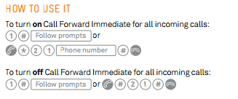
Call charges may apply for the calls you forward.

*Note: Please check your telephone’s Operating Manual for information on Call Forwarding in the event the above is unsuccessful.

Key Register
Key Register
Office Keys
Staff Name | Key Number | Location

Hazard Report Form

HAZARD REPORT

Reported By:
Name: _____________________ Position: _____________ Date: ________

Reported To:
Name: _____________________ Position: _____________ Date: ________

Department/Area: _______________________________

Subject:

( ) Incident ( ) Near Miss ( ) Workplace Hazard

( ) Hazardous Work Practice

Description of Incident/Hazard

What needs to be done?

Signature: ______________________________ Date: __________________

Copy given to: Supervisor: ________________________________________

Employee Name: ____________________________________

Thermotec Group Pty Ltd

Job Safety Check

Injury/Incident Report
Thermotec Group Pty Ltd

INJURY/INCIDENT REPORT

Surname: _______________________ Gender M/F: __________________

Other Names: _______________________________________________________

Department/area: ____________________________________________________

Date of Injury: ____________________ Time: ________________________

Description of Injury: _____________________________________________

___________________________________________________________________

Injury type e.g. cut/strain, burn etc. _____________________________________

___________________________________________________________________

Location where injury/incident occurred: ________________________________

Witnesses: (Name and contact number or address:

- ______________________________________________________________

- ______________________________________________________________

Employee/Supervisor signature: _____________________________ (Which)

Date: ____________________________________________________

Has a WorkCover claim been made: __________ Yes __________ No

This form must be forwarded to : ______________________________________

Within 24 hours of the incident.

RICE Principal

Rest
Rest is a key component of repairing the body. Without rest, continual strain is placed on the affected area, leading to increased inflammation, pain, and possible further injury. Additionally, some soft tissue injuries will take longer to heal without rest. There is also a risk of abnormal repair or chronic inflammation resulting from a failure to rest. In general, the period of rest should be long enough that the patient is able to use the affected limb with the majority of function restored and pain essentially gone.

Ice
Ice is excellent at reducing the inflammatory response and pain associated with heat generated by increased blood flow and/or blood loss. A good method is applying ice for 20 minutes of each hour. Other recommendations are an alternation of ice and no-ice for 15–20 minutes each, for a 24–48 hour period. To prevent localised ischemia or frostbite to the skin, it is recommended that the ice be placed within a towel or other insulating material before wrapping around the area.
Exceeding the recommended time for ice application may be detrimental, as it has been shown to delay healing.

Compression
Compression aims to reduce the edematous swelling that results from the inflammatory process. Although some swelling is inevitable, too much swelling results in significant loss of function, excessive pain and eventual slowing of blood flow through vessel restriction.
An elastic bandage, rather than a firm plastic bandage (such as zinc-oxide tape) is required. Usage of a tight, non-elastic bandage will result in reduction of adequate blood flow, potentially causing ischemia. The fit should be snug so as to not move freely, but still allow expansion for when muscles contract and fill with blood.
Compression stockings or sleeves are a viable option to manage swelling of extremities with graduated compression (where the amount of compression decreases as the distance to the heart decreases). These garments are especially effective post-operatively and are used in virtually all hospitals to manage acute or chronic swelling, such as congestive heart failure.

Elevation
Elevation aims to reduce swelling by increasing venous return of blood to the systemic circulation. This will result in less edema which reduces pain or swelling.

DRABCD Principle

DANGER
Ensure the area is safe for yourself, others and the patient.
RESPONSE
Check for response—ask name—squeeze shoulders
No response Response
• Send for help. • make comfortable
• Check for injuries
• monitor response.
SEND for help
Call Triple Zero (000) for an ambulance
Or ask another person to make the call.
AIRWAY
Open mouth—if foreign material is present:
• Place in the recovery position
• Clear airway with fingers.
Open airway by tilting head with chin lift.
BREATHING
Check for breathing—look, listen and feel.
Not normal breathing Normal breathing
• Start CPR. • Place in recovery position
• monitor breathing
• manage injuries
• treat for shock.
CPR
Start CPR—30 chest compressions: 2 breaths
Continue CPR until help arrives
Or patient recovers.
DEFIBRILLATION
Apply defibrillator if available
And follow voice prompts.
First Aid | 1300

Application for Leave Form
Thermotec Group
PO Box 4064
Mildura, VIC 3502

APPLICATION FOR LEAVE

NAME: ………………………………………………............

POSITION: ………………………………………………............
STATUS: (Please circle): PERMANENT / CASUAL
FIRST DATE ABSENT: ……/……/………
LAST DATE ABSENT: ……/……/…........
TOTAL DAYS ABSENT: ……………………………………………….............
NATURE OF LEAVE: ......................................................................................
(I.e. Annual Leave, Sick Leave, Unpaid Leave, Bereavement etc.)
REASON: ......................................................................................
(Where sick leave is claimed, a doctor’s certificate will be required for Monday & Friday’s, 2 or more consecutive days, or immediately before or after a Public Holiday.)
APPLICANT SIGNATURE: ......................................................................................
DATE
APPROVED: YES / NO
(Office use only)

NB. Whilst every effort will be made to accommodate requests for Annual Leave, some dates may be subject to staffing requirements. Please submit requests at least two (2) weeks in advance. It is in your best interest to submit your Leave Form as early as possible. Do not book flights or accommodation etc. until leave has been approved.

Employee Warning Notice
Employee Warning Notice
Employee Information
Employee Name: |  |  |  |  |  | Date:
Employee ID: |  |  |  |  |  | Job Title:
Manager: |  |  |  |  |  | Department:
Type of Warning
 | First Warning |  |  |  | Second Warning |  |  |  | Final Warning
Type of Offense
 | Tardiness/Leaving Early |  |  |  | Absenteeism |  |  |  | Violation of Company Policies
 | Substandard Work |  |  |  | Violation of Safety Rules |  |  |  | Rudeness to Customers/Co-workers
 | Other:
Details
Description of Infraction:
Plan for Improvement:
Consequences of Further Infractions:
Acknowledgement of Receipt of Warning
By signing this form, you confirm that you understand the information in this warning. You also confirm that you and your manager have discussed the warning and a plan for improvement. Signing this form does not necessarily indicate that you agree with this warning.
Employee Signature |  |  |  |  |  |  |  |  | Date
Manager Signature |  |  |  |  |  |  |  |  | Date
Witness Signature (if employee understands warning but refuses to sign) |  |  |  |  |  |  |  |  | Date

Thermotec Meeting Minutes templete

Date: |  | Meeting Time: |  |  | Meeting Location:
Meeting Called by
Type of meeting
Facilitator
Note Taker
Attendees
Agenda Topic:
Discussion
Conclusions
Action Items |  |  | Person Responsible |  | Deadline
Agenda Topic:
Discussion
Conclusions
Action Items |  |  | Person Responsible |  | Deadline
Agenda Topic:
Discussion
Conclusions
Action Items |  |  | Person Responsible |  | Deadline

Payroll Deduction Authorisation Form
Personal Deduction Authorization Form
Personal & Confidential
Employee Name: |  | Employee ID No.:
Date Effective:
Item of Deduction | Date of Purchase | Supplier | Invoice Number | Total Requested Amount
 |  |  |  | $ -
 |  |  |  | $ -
 |  |  |  | $ -
 |  |  |  | $ -
 |  |  |  | $ -
 |  |  |  | $ -
 |  |  | Running Total | $ -
Deduction Amount per Pay Period
$ -
I hereby authorize Thermotec Group Pty Ltd to make the above deductions from my pay (at a rate of no less
than 10% of the total original value) in accordance with the above terms.
I understand and agree that I am responsible for satisfying the above amounts. I understand and agree that
any amount that is due and owing at the time of my termination, regardless of whether my termination was
voluntary or not, will be deducted from my last pay check.
 |  |  |  | Signed:
Authorised by:
 |  |  |  | Date:
Employee Signature:

Creating a job on SimPRO
Step 1: Select “Jobs” tab in top centre of screen. Hover right to “Create New” and select “+Service Job”.
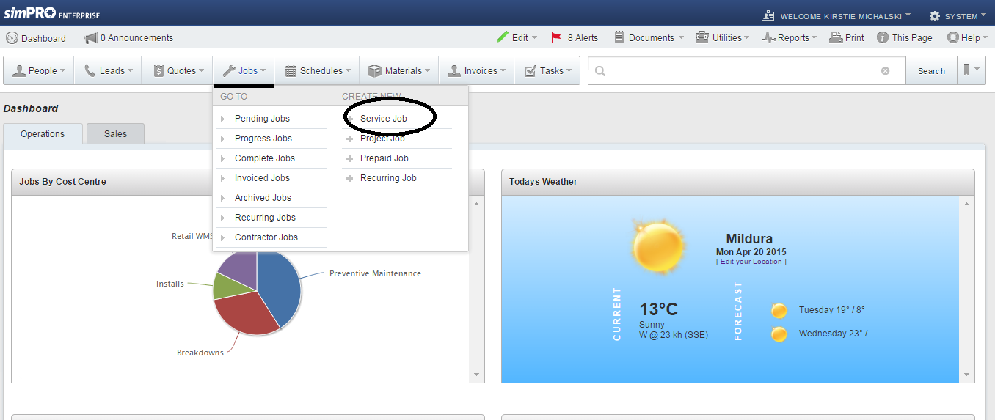
Step 2: Start typing in Customer Name. A drop down box will appear. Choose the customer, and repeat process for site. Fill in all the other boxes as required.
Note: Boxes marked with * are mandatory.
Once completed, click “Next” (green button on top of right hand side)
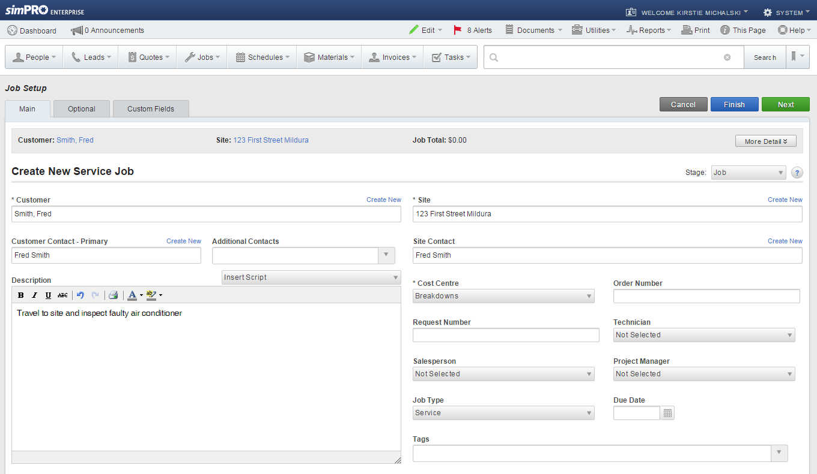

Step 3: This will take you to the page below. Click on the “Finish” button.
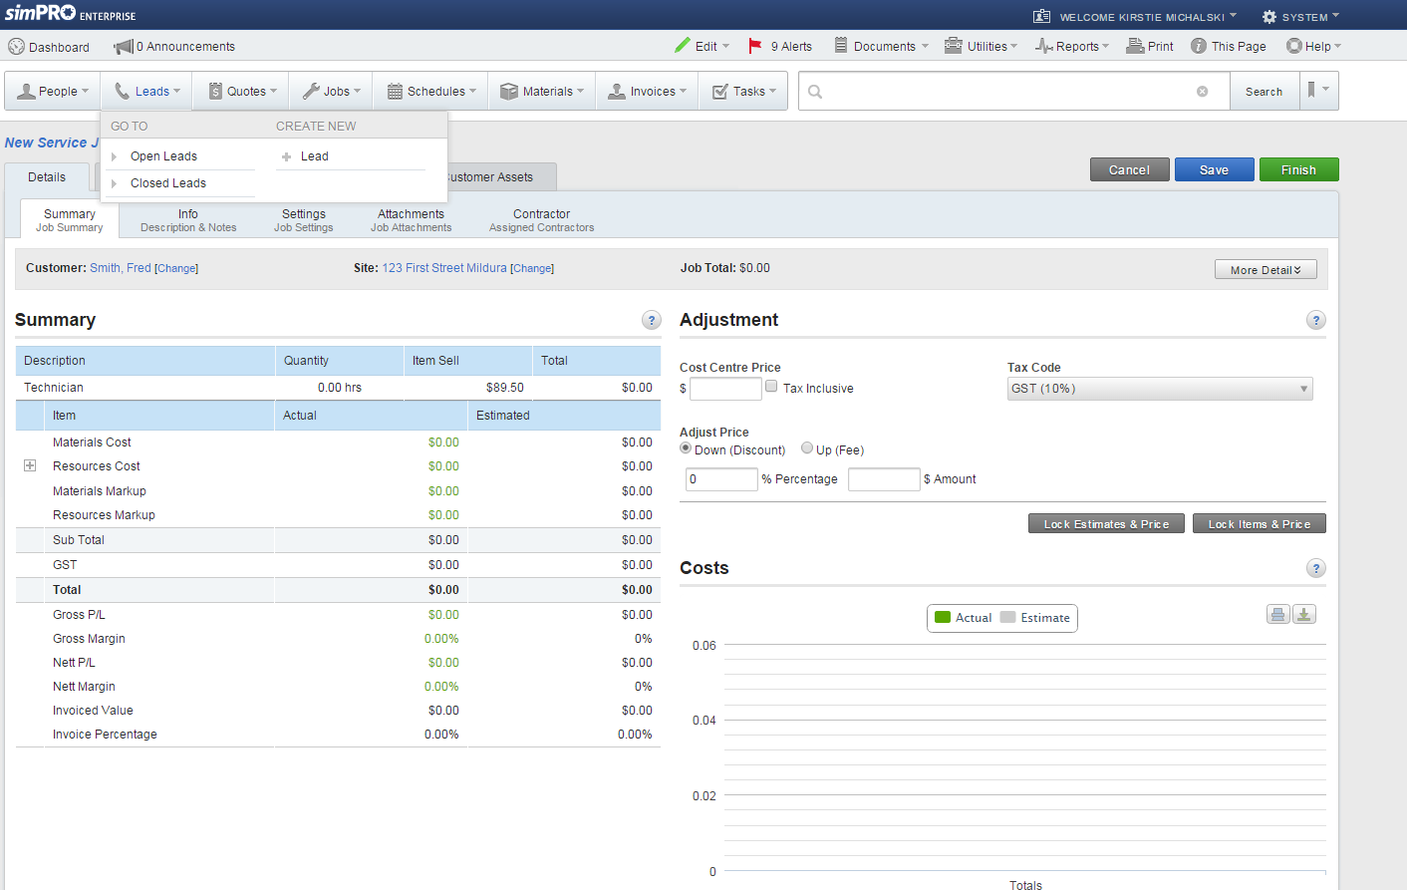

Step 4: The following window will appear. Click on “Schedule Job” to allocate job to your technician.
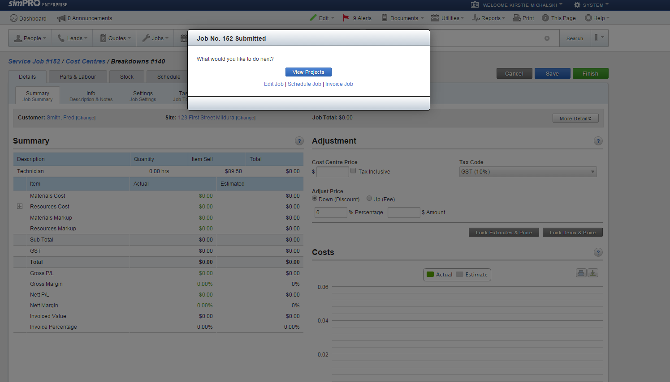
Step 5: You will need to select your Technician from the drop down box as shown below.
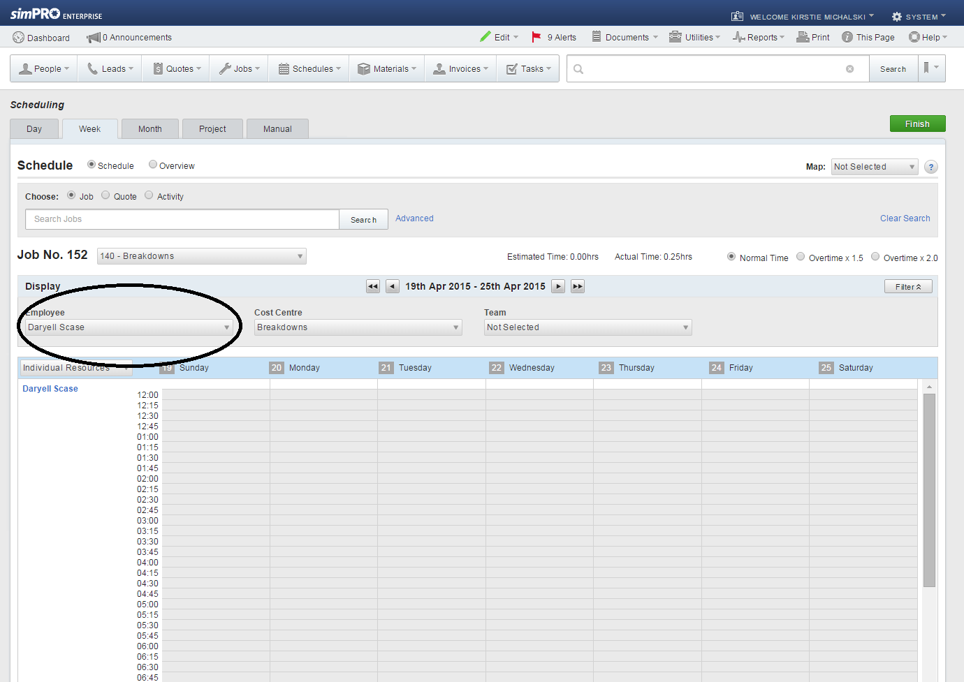

Step 6: Click on the start time that you want to allocate the job for, and drag down until you get to your end time (Below in green). Then click on the green “Finish” button on the right hand corner. Your job is now scheduled to the technician.
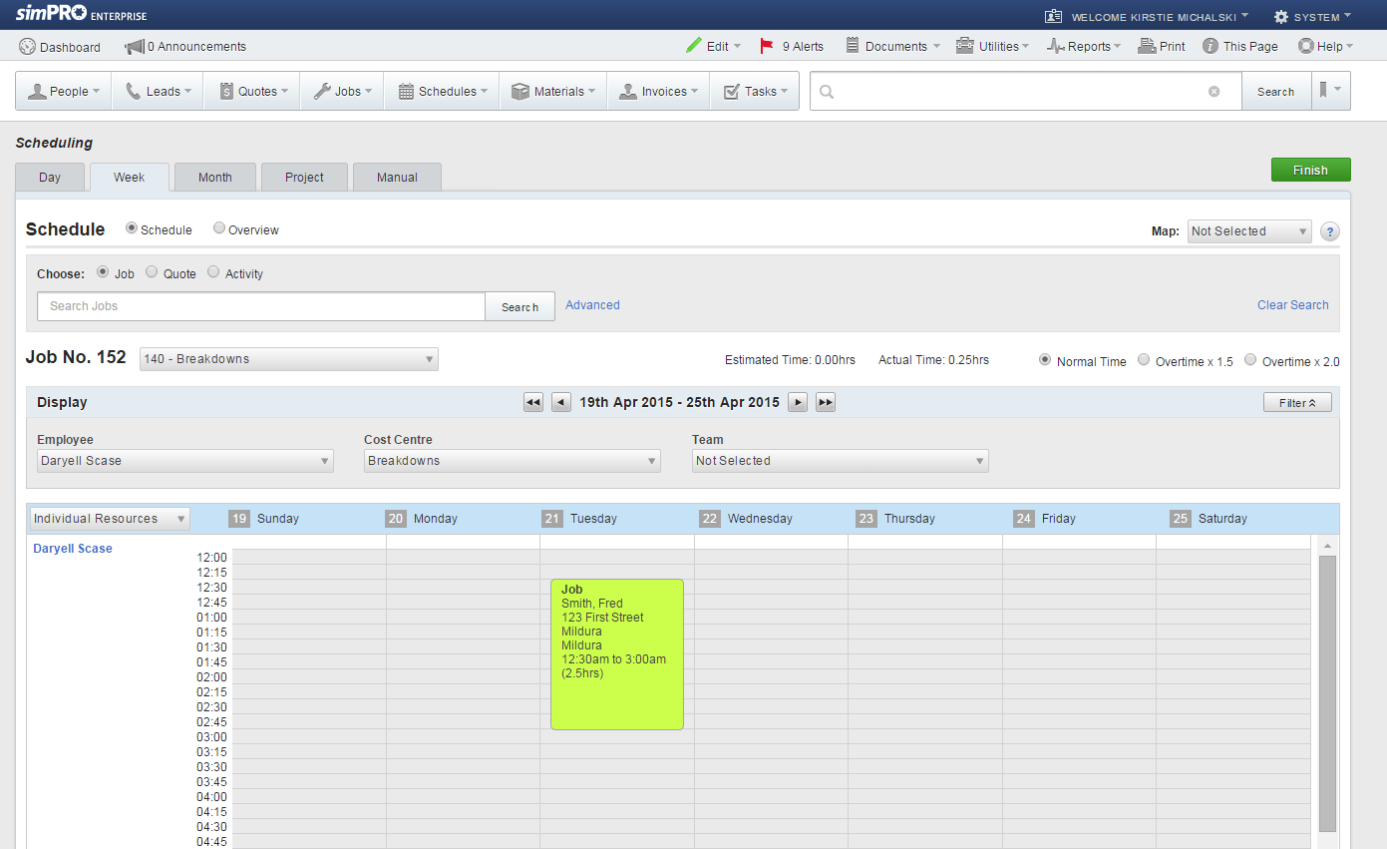

Creating a purchase order on SimPRO
Step 1: Select “Materials” tab on top of screen (red arrow below). Hover right to “Create New” and select “+PO Number”.
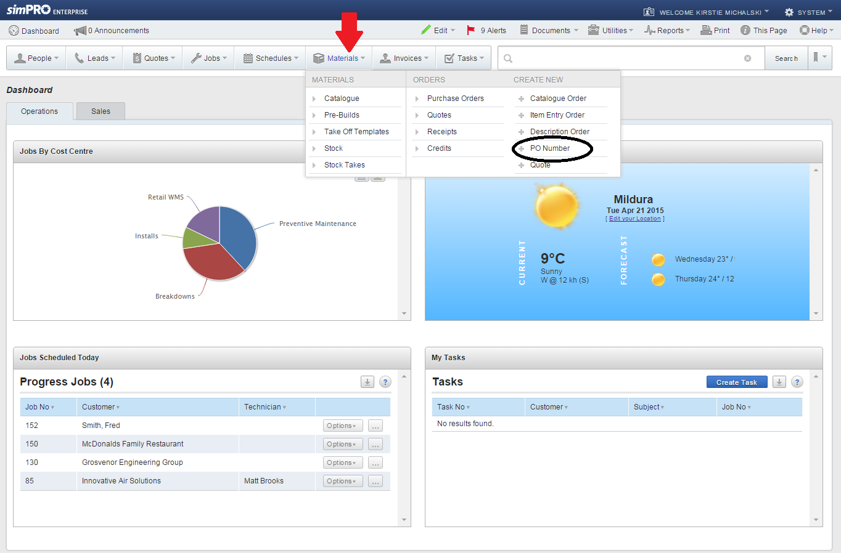

Step 2: You will need to assign the order to either Stock or a Job. Change the “Storage Device” tab to where you would like the item to be assigned to. Then click on either the ‘Job’ circle, and type in your job number or the ‘Stock; circle .
Select your supplier by dropping down the “Supplier” tab. An order number will be automatically generated for this order. Put any reference numbers in the “Reference Number” tab. You can also add any notes you may want to the ‘Supplier Notes’ section.
Once completed, click the green “Finish” button in the top right hand corner. This will generate your order number

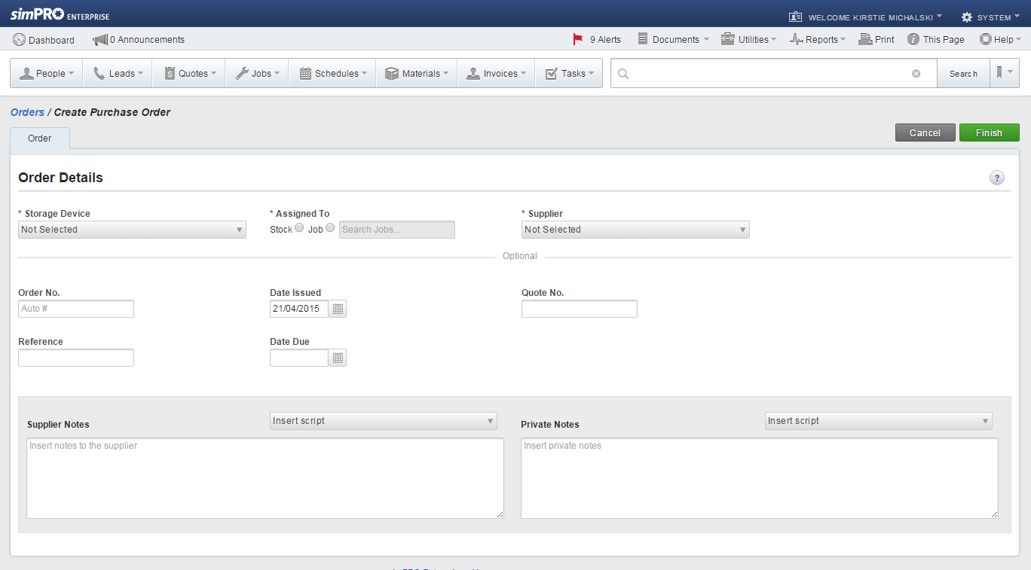

Step 3: You will be taken to the below window. Click on the ‘Unlock’ button which will allow you to add items to your order. Then click on the Order tab.
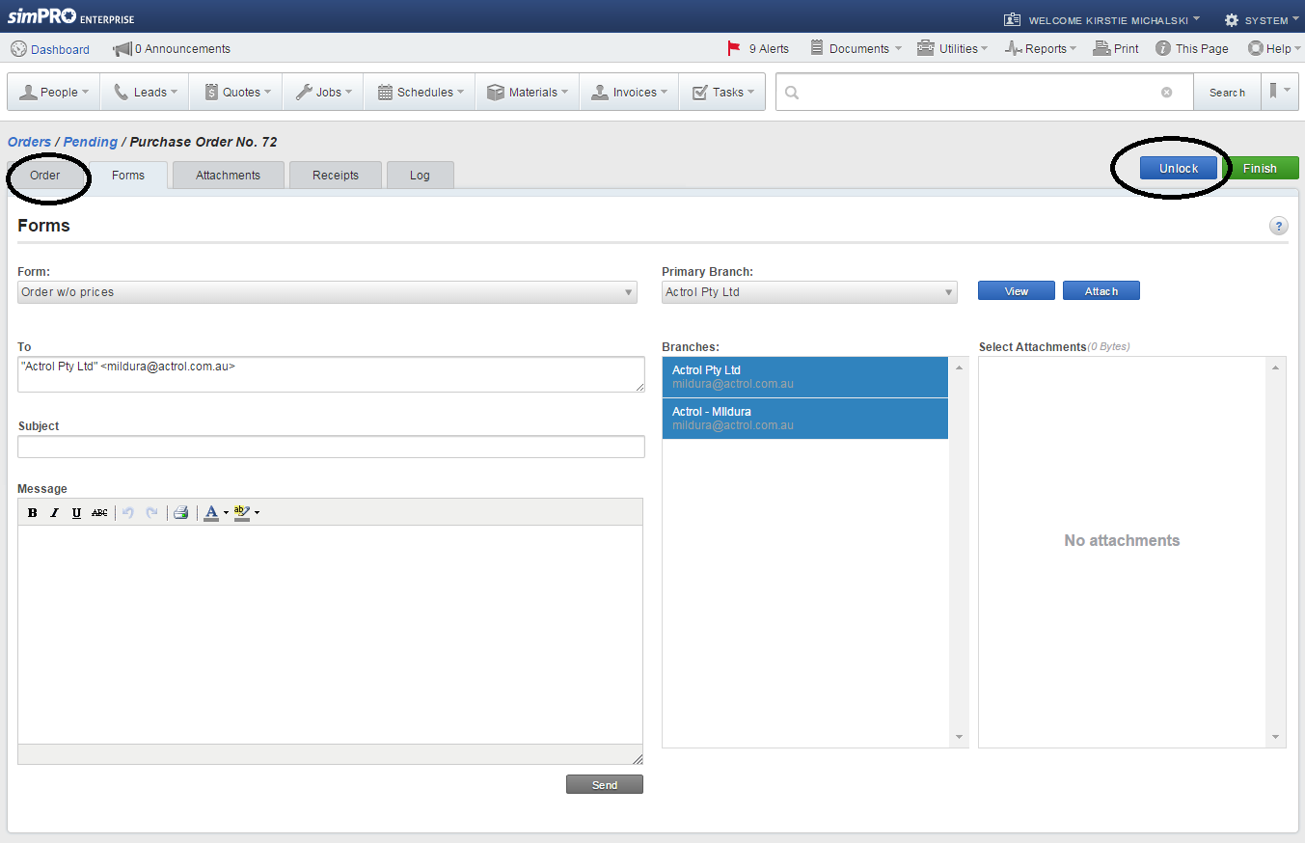

Step 4: Click on the “Add New Item” button.
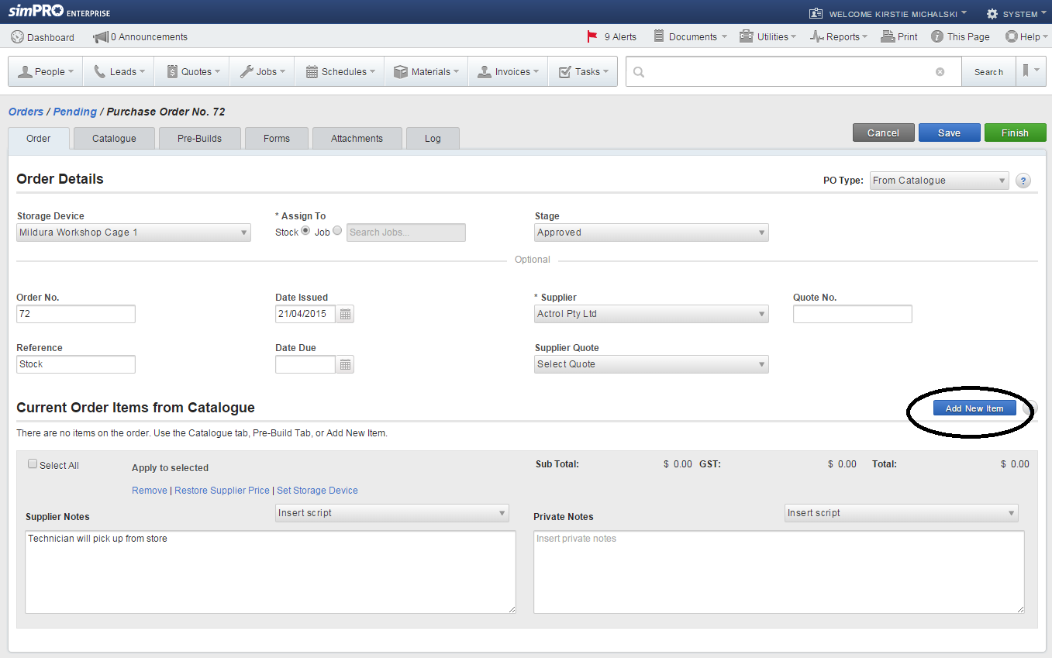

Step 5: The following window will appear. Fill in the required sections making sure to include prices if known. Click the “Save” button, then the “Finish” button.
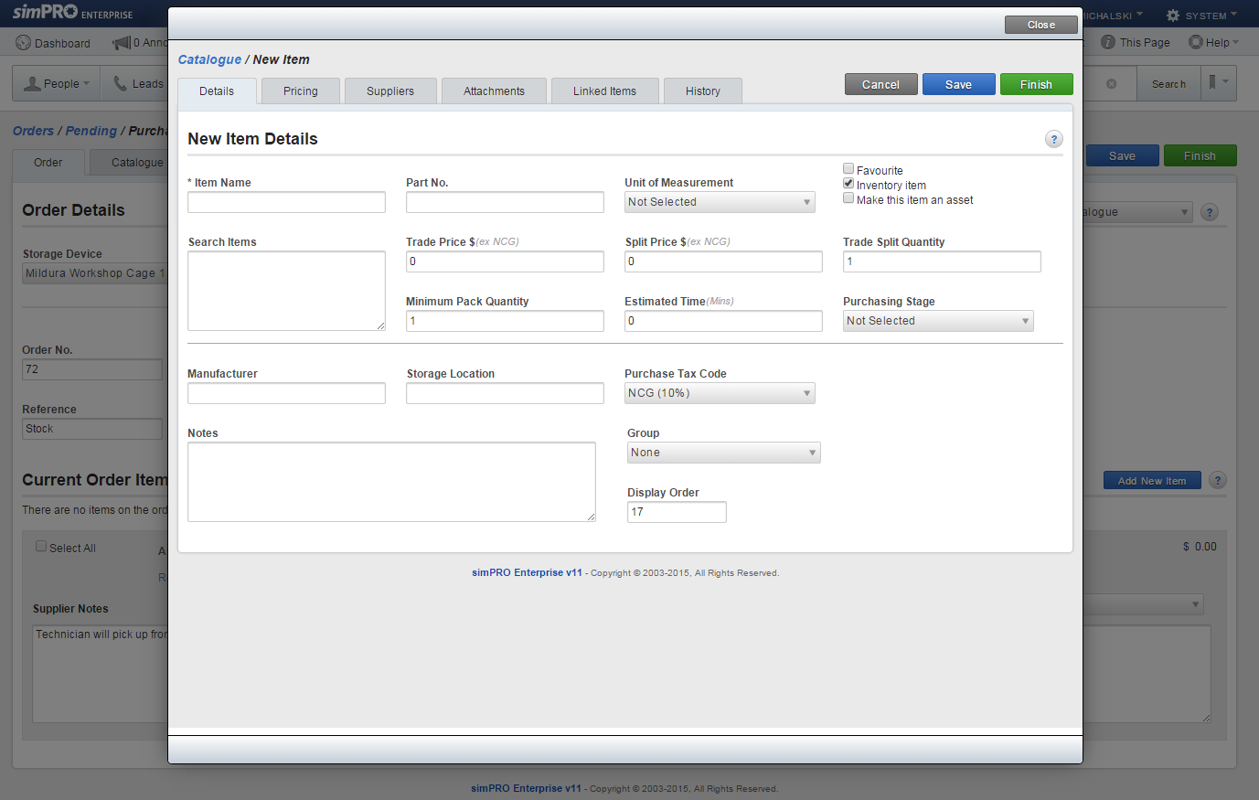
Step 6: You will be taken to the below window. From here, click on the “Forms” tab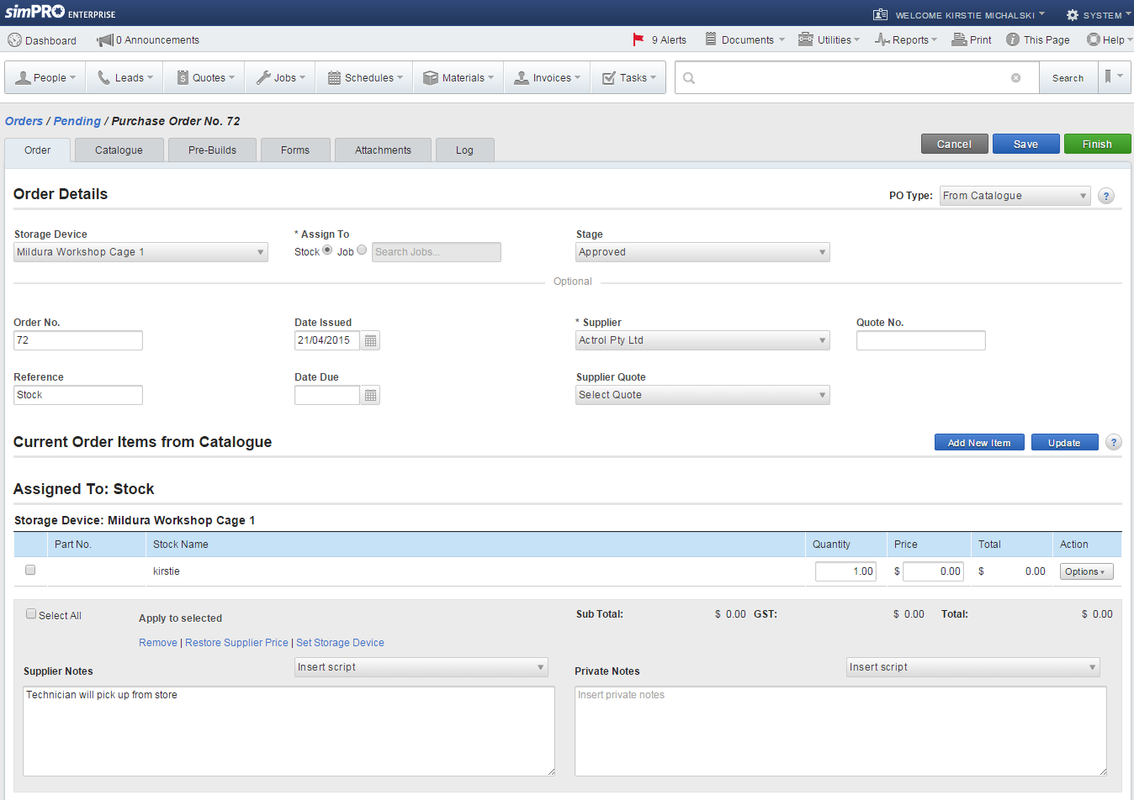

Step 7: You can either click on “View” to view the Purchase Order and print it out, or “Attach” to attach the order to the form so that you are able to send it as an email. Click ‘Send’ to email order to the supplier. Click on the finish button once you are done.
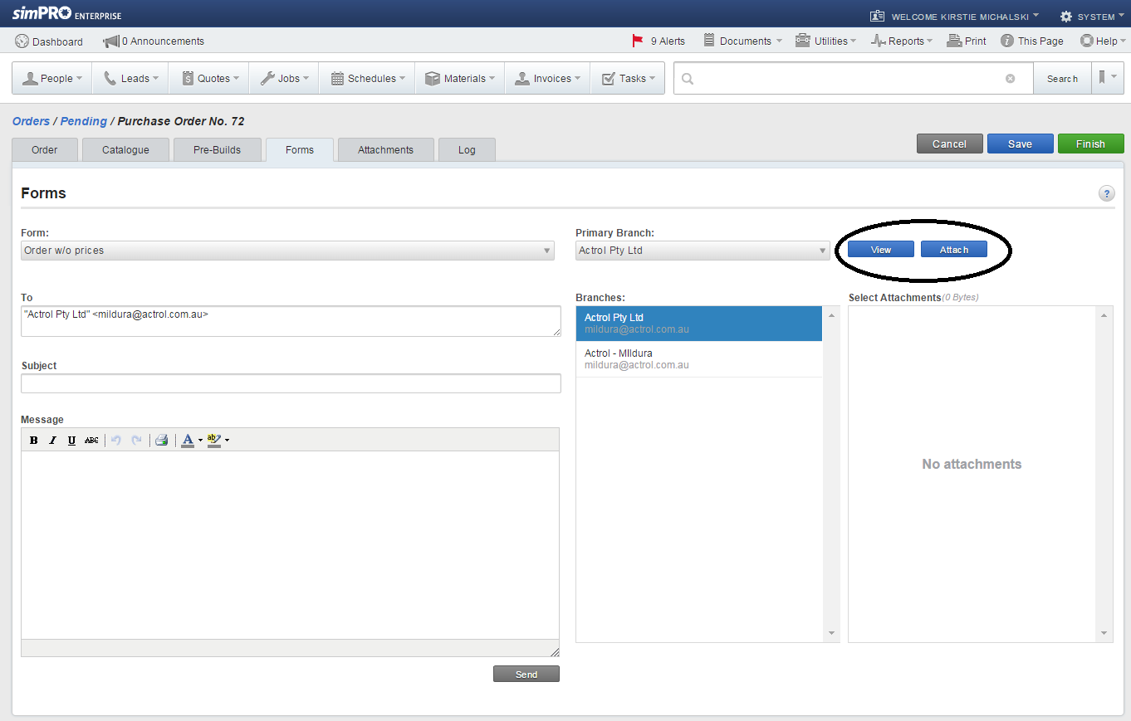

Creating a quote on SimPRO-
Step 1: Select the “Quotes” tab in the centre of the screen. Hover right to “Create New” and select “+Service Quote”.

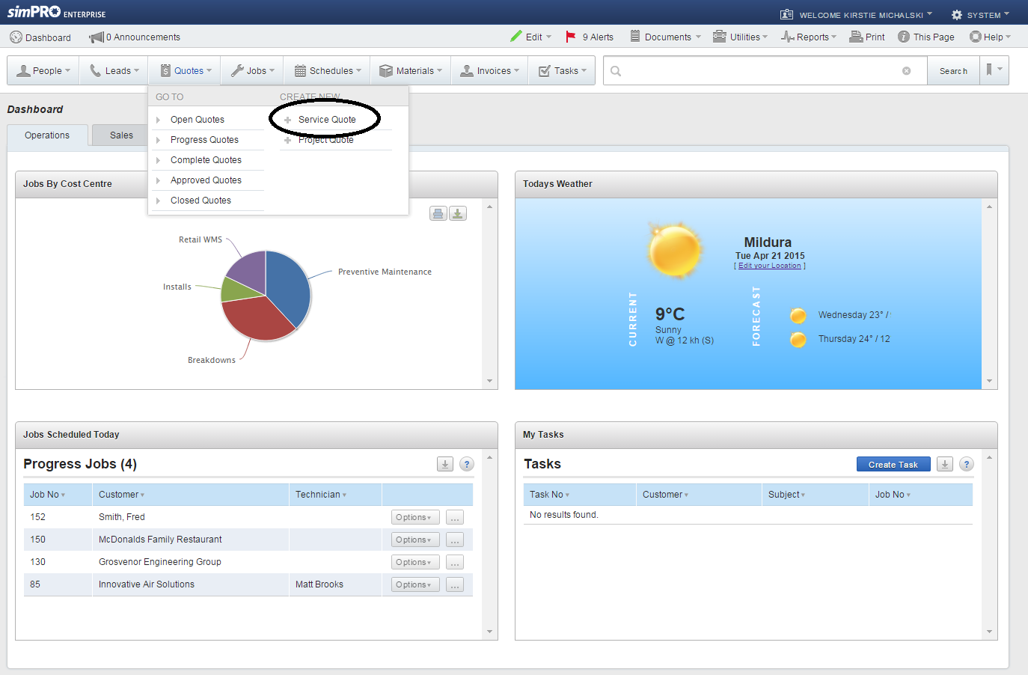

Step 2: You will then be taken to the following window. Click on the “Parts & Labour” Tab so you can start adding items onto your quotation.
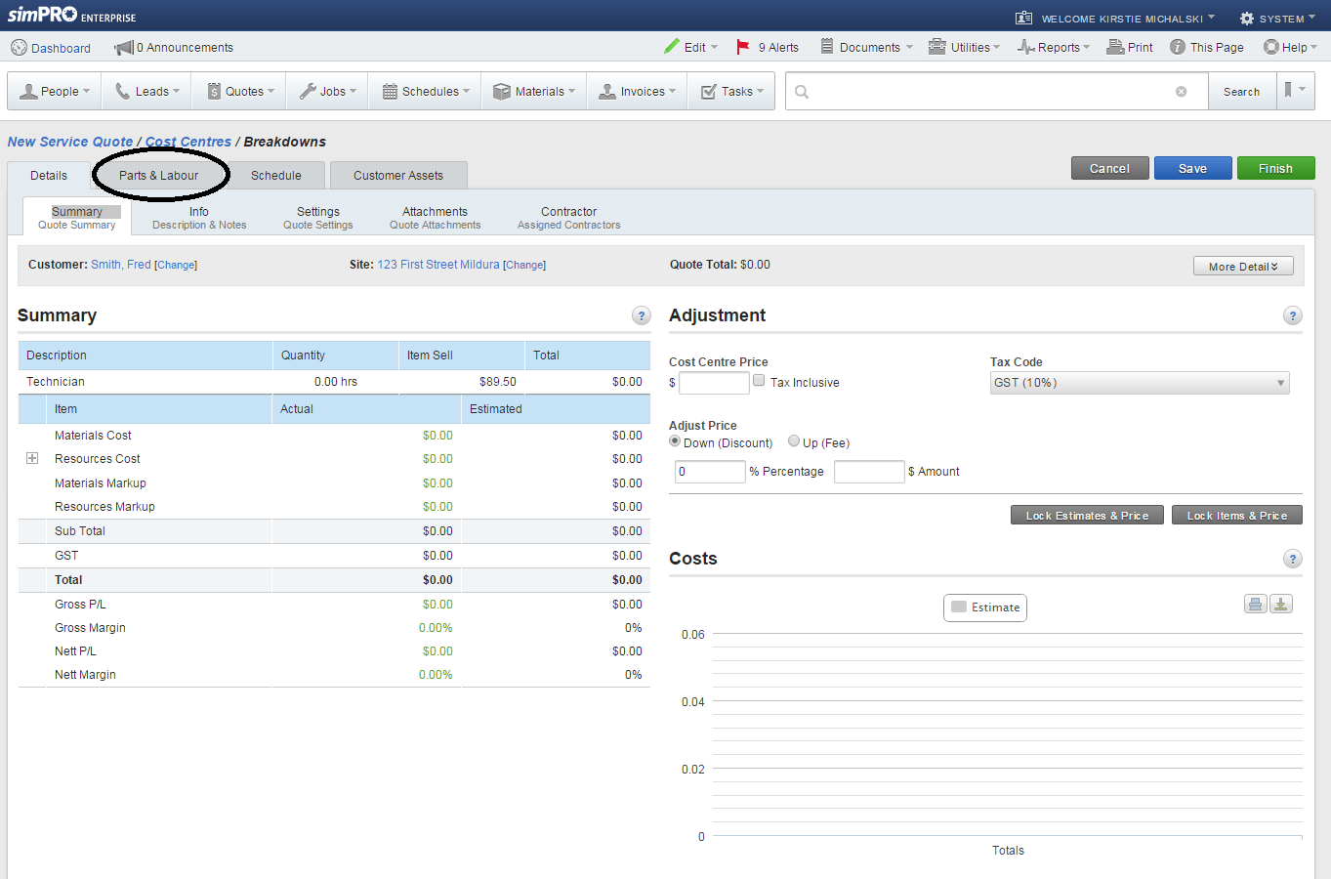

Step 3: You can then add your parts from either of the below categories, along with your labour. After you have done this, click save.
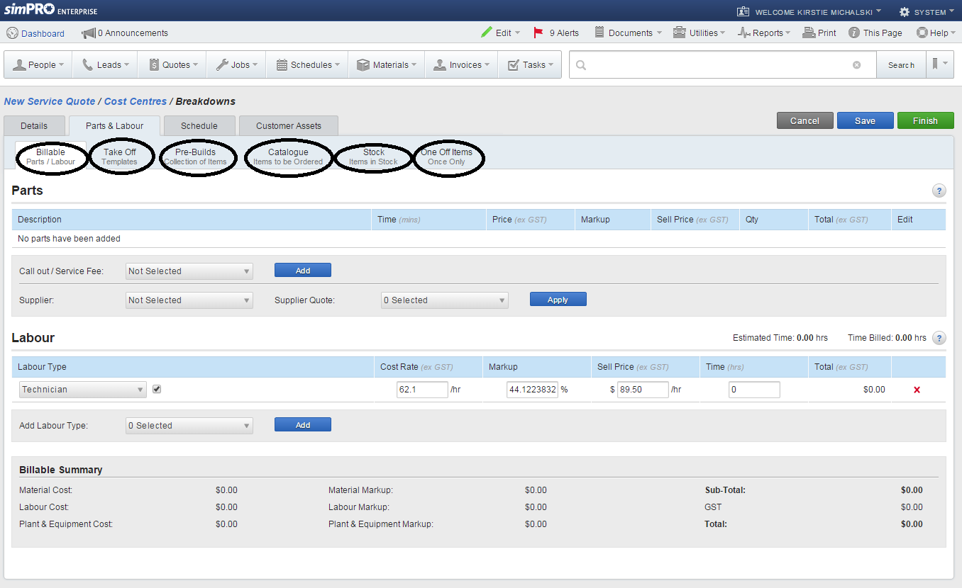

Step 4: Click on “Info” tab. You can then write in any notes that you want to add to the quotation. Once you have finished, click on the “Finish” tab.
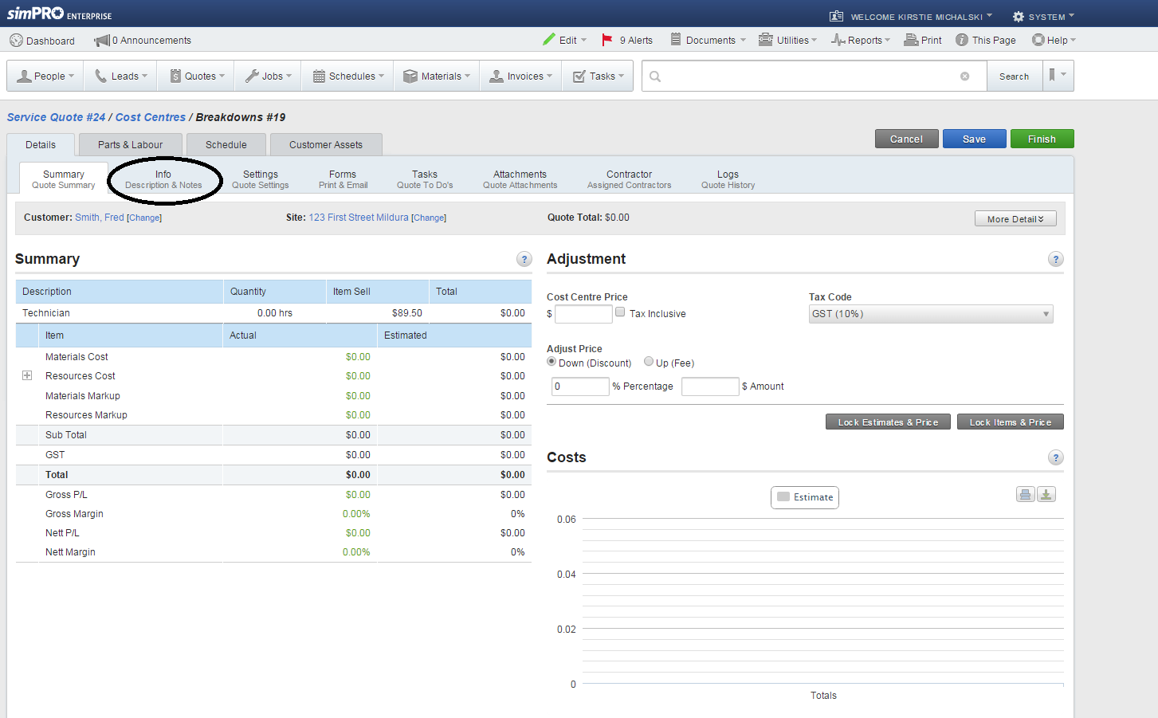

Step 5: The following window will appear. You can either click on “View Projects” to take you to the ‘Open Quotes’ list, or “Convert to” tab which will allow you to convert the quotation to a job.
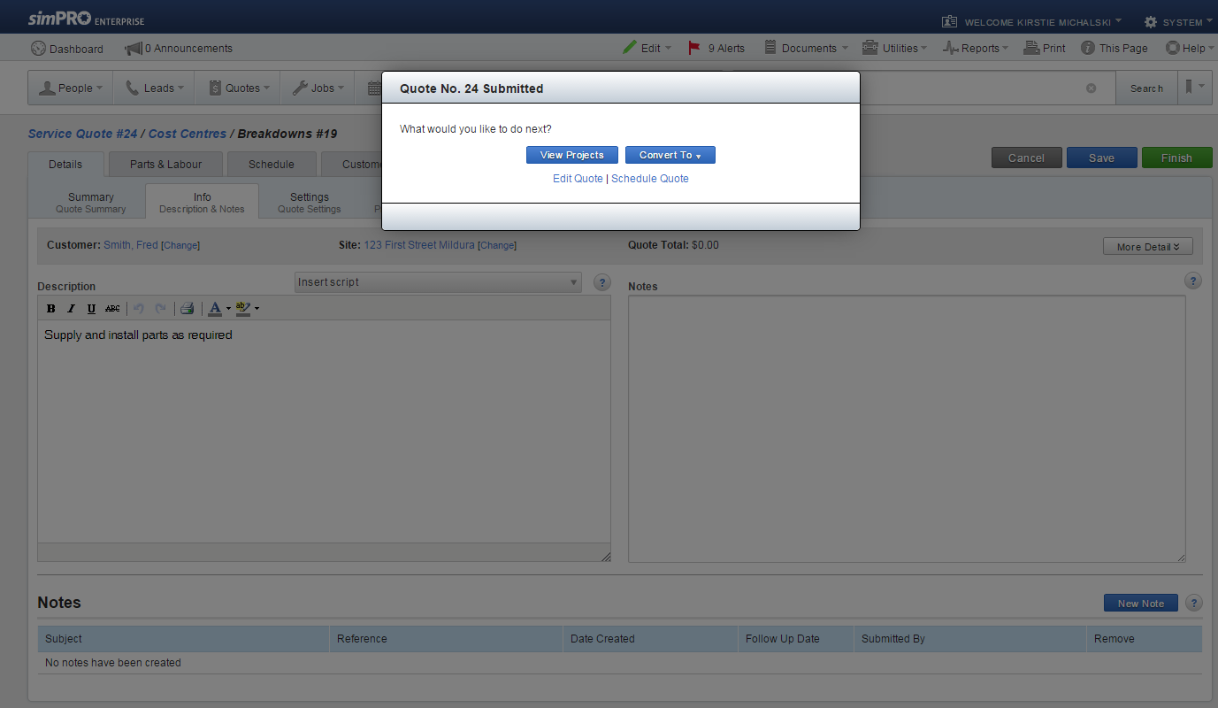

How to use Connect app for tablet
HOW TO USE CONNECT APP –SIMPRO CREATED JOBS
- Log onto connect and sync back to Simpro
- Check schedule for today’s jobs
- Select job , read description of works and attachments
- Check for any additional tasks required on this job
- When ready to go to site press START TRAVEL tab
- Once arrived on site press START WORK tab
- Carry out works as per description/attachments (inc job upgrades as required)
- List materials used on job either from catalogue/stock or note “one off” items
- Advise customer of works carried out get all paperwork and device signed
- Review scheduled times on job adjust as required
- Submit job with a status ie. Parts required ,completed etc.
- Move onto next scheduled job and/or check tomorrow’s jobs

HOW TO CREATE A PURCHASE ORDER ON CONNECT
- Select PO`s from the main menu (left top screen)
- Click “ADD NEW PO” tab
- Select your supplier from drop down box
- Type in notes if “one off” item (item not in a catalogue or stock)
- Click REQUEST PO tab and an order # will be auto generated
- If selecting “one off” item click FINISH then attach photo of docket (order#28)
- If selecting from catalogue click ADD MATERIALS then FROM CATALOGUE
- Select materials and quantities required
- Press ADD PARTS tab
- Once completed select FINISH tab
- Review order then click FINISHED to complete

NOTE -If multiple suppliers were selected it will create multiple PO`s

Example phone message memo
Phone Message
Name
Residential Address
Postal Address
Phone Number
Mobile Number
Email Address
Commercial or Domestic
Details of Call:
Model:
Serial:
How long has fault been occurring?

Alarm Access Code Register

Alarm Access Code Register
Number | Staff Member

Tablet RegisteR
Tablet Register
Staff Name | Serial Number | IMEI Number | Service Number | Sim Card Number | iPad Number | Recharged | Condition of iPad
Note: To recharge, go to m.telstra.com on device.

Vehicle Register
Vehicle Register
Staff Member | Make/Model | Registration | Date of Renewal

Phone Register
Phone Register
Staff Name | Phone Number | Make/Model | Condition of Phone

Passwords Register Templete
SimPRO
Staff Member | Username | Password

Parts Inventory
Part Number | Brand | Description | Quantity | Location | Minimum Stock Level

Customer Feedback Form

 |  |  | Customer Feedback Form
1. Customer details
Title (Mr, Mrs, etc.) |  | Family name |  |  |  |  |  |  | Given Name
Street address |  |  |  |  |  |  |  |  | Suburb |  |  |  |  | Postcode
Home Telephone Number |  |  |  |  |  | Business Telephone Number |  |  |  |  |  | Mobile Telephone Number
Email address (if applicable)
2. Details of other person or supplier involved in this feedback
Name
Street address |  |  |  |  |  |  |  |  | Suburb |  |  |  |  | Postcode
Home telephone number |  |  |  |  |  |  | Business telephone number |  |  |  |  | Mobile telephone number
Email address (if applicable)
3. Details of goods or services supplied to the customer
Date of Purchase or service
Description of the goods or service including make, model, type of service, purchase method, etc.
4. Details of the customer feedback
……………………………………………………………………………………………………………………………………………..…
Office use only
Feedback received by |  |  |  |  |  |  |  | Date received |  |  |  | In person/Writing
Action taken or required
Date action completed |  |  |  | Signature |  |  |  |  |  |  |  |  | Job number

Plant & EquipmentRegister
Asset # | Make | Model | Serial | D.O.P | Colour | Location

Technical Information
Technical information will be available in the “Technical Information” manual

